Competing from the
Holy of Holies
Learning to Enjoy the Process of Running an Equine, Ranching or
Rodeo Business without Losing Our Identity in Christ.

Malachi 4:5-6

Proverbs 22:6
“For God did not give us a Spirit of FEAR but of POWER,
LOVE and a SOUND MIND.” (2 Timothy 1:7)

By: Wade Black

Fall Section

Horsemanship:
Wade’s Personal Testimony
Reading Material: “Returning to Eden: True Unity and Willing
Communication Between God and Man”

Bronc Riding:
Strongholds
Reading Material: “Competing from the Holy of Holies”
Online Bible Study Videos

Time:
Spiritual Warfare
Reading Material: “Competing from the Holy of Holies”
Online Bible Study Videos

Week 1 - Training for the Cross
Training Kids through Training Horses

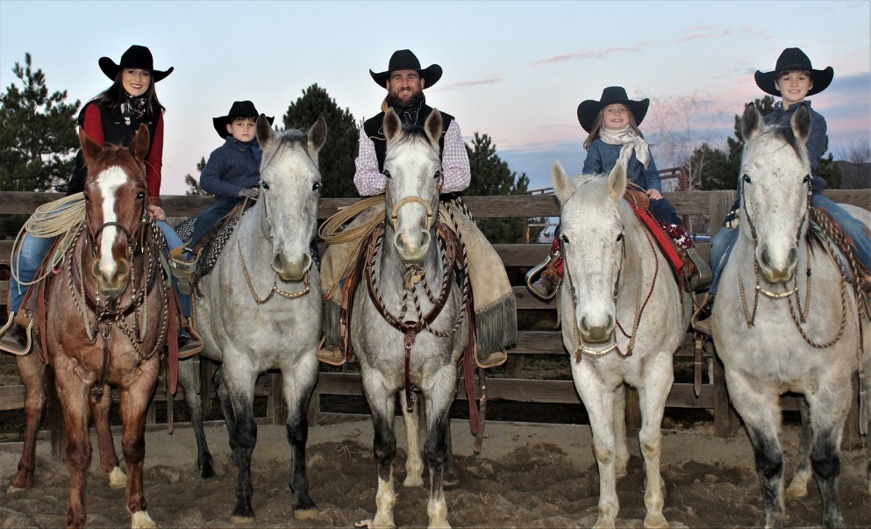
"Therefore, go and make disciples of all nations, baptizing them in the name of the Father and of the Son and of the Holy Spirit, and teaching them to obey everything I have commanded you." (Matthew 28:19-20)
In my business and marketing class I teach at TVCC I have my students ask people that they feel have lived a successful life for “Pearls of Wisdom.” These could be ideas, morals, or beliefs that they have chosen to live their life by, and feel have helped them achieve success. I tell my students be sure to ask them not only the “what to do’s,” but almost as important are the “what not to do’s.” We will call these “Pearls of Wisdom” because many may have been learned through adversity or trials. I don’t think many of us join or enter anything to experience failure, however many times as believers we are not walking in the victory (1 Corinthians 15:57; 1 John 5:4) that the Bible says we are entitled to.
Romans 8:14 says, “For as many as are led by the Spirit of God, they are the sons of God.” Something I missed for many years in running my business is what it means to be “led by the Spirit” with a son mentality, or led by the flesh with an orphan mentality, and how extremely important it is to recognize the difference. Romans 8:5-8 says, “Those who live according to the flesh have their minds set on what the flesh desires; but those who live in accordance with the Spirit have their minds set on what the Spirit desires. The mind governed by the flesh is death, but the mind governed by the Spirit is life and peace. The mind governed by the flesh is hostile to God; it does not submit to God’s law, nor can it do so. Those who are in the realm of the flesh cannot please God.” This is something we will be talking about in nearly every lesson, what it means to be “in” the flesh and “in” the Spirit, and how vitally important it is to know the difference as we are making business decisions and trying to raise a family. Because in every decision we make, we are either minding the things of the flesh that will lead to death and not please God or minding the things of the Spirit that will bring “life and peace.”
I became alive as a son of God in high school, however in making many decisions I have failed to be led by the Spirit and God’s Word. Joshua 1:8 says, “Do not let this Book of the Law depart from your mouth, meditate on it day and night, so that you may be careful to do everything written in it. Then you will be prosperous and successful,” and Psalms 1:1-3 says, “Blessed is the man that walks not in the counsel of the ungodly, nor stands in the way of sinners, nor sits in the seat of the scornful. But his delight is in the law of the LORD; and in his law he meditates day and night. He shall be like a tree planted by the rivers of water, that brings forth his fruit in his season; his leaf also shall not wither; and whatsoever he does shall prosper.” There is a lot that I still need to learn about running a successful business as a son of God. However, one thing I have learned is the importance of meditating on God’s Word daily.
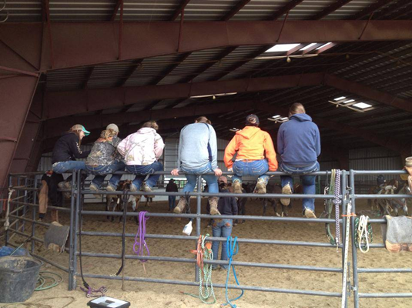
My job at TVCC is to water seeds. Some kids come to TVCC with a seed planted in their heart to run a successful equine business, some have a seed for rodeo, or ranching, some have a seed to be a son of God and some are on the fence and not sure what they want to do. The purpose of Ranch Roping Discipleship and the Gideon’s 300 Bible Study is to help Christian men and women that desire to be a child of God and be successful in the equine, ranching, and rodeo industries.
I did not realize at sixteen years old when I prayed a prayer at a rodeo Bible camp and surrendered my life to be used to build His kingdom that I entered a new reality. I entered a new reality with a new set of rules and guidelines (the Kingdom of Heaven), which is the exact opposite of the reality I spent most of my life living in up to that point. In the Kingdom of Heaven when you are weak you are strong (2 Cor 12:10) and to become wise we must become a fool. (1 Cor 3:18) I guess this is why He let me receive a sickness that affects my physical strength and mental clarity, and then told me to ride broncs, get my masters and run a colt starting business. God wanted to help me learn how to, “Walk in the Spirit, and you shall not fulfill the lust of the flesh. For the flesh lusts against the Spirit, and the Spirit against the flesh: and these are contrary the one to the other: so that ye cannot do the things that ye would.” (Gal 5:16-17)
God has basically shown me that trying to run a successful business as a son of God is a lot like being successful ranch roping. Both have five areas that need continual focus and whenever these get overlooked or out of balance, we have the potential of not only looking really stupid, but possibly hurting ourselves or someone else.

1) Horsemanship
- Foundation (“Who we are in Christ”)
Luke 6:48 - He is like a man who built a house, and dug deep, and laid the foundation on a rock: and when the flood arose, the stream beat vehemently upon that house, and could not shake it: for it was founded upon a rock.
Matthew 16:15-20 - “But what about you?” he asked. “Who do you say I am?” Simon Peter answered, “You are the Messiah, the Son of the living God.” Jesus replied, “Blessed are you, Simon son of Jonah, for this was not revealed to you by flesh and blood, but by my Father in heaven. And I tell you that you are Peter, and on this rock, I will build my church, and the gates of Hades will not overcome it. I will give you the keys of the kingdom of heaven; whatever you bind on earth will be bound in heaven, and whatever you loose on earth will be loosed in heaven.”
2) Stockmanship
- Spiritual Discernment
Hebrews 4:12 - For the word of God is quick, and powerful, and sharper than any two edged sword, piercing even to the dividing asunder of soul and spirit, and of the joints and marrow, and is a discerner of the thoughts and intents of the heart.
2 Corinthians 10:3-5 – For though we walk in the flesh, we do not war after the flesh: For the weapons of our warfare are not carnal, but mighty through God to the pulling down of strong holds; Casting down imaginations, and every high thing that exalts itself against the knowledge of God, and bringing into captivity every thought to the obedience of Christ.
3) Roping
- Spiritual Gift
Ephesians 4:8- Wherefore he says, when he ascended up on high, he led captivity captive, and gave gifts unto men.
1Timothy 4:14 - Neglect not the gift that is in thee.
2Timothy 1:6- Wherefore I put thee in remembrance that thou stir up the gift of God, which is in thee by the putting on of my hands.
4) Teamwork
- Functioning in the Body of Christ
Romans 12: 4, 5 – Just as each of us has one body with many members, and these members do not all have the same function, so in Christ we who are many form one body, and each member belongs to all the others.
Ephesians 4:11-14 - And he gave some, apostles; and some, prophets; and some, evangelists; and some, pastors and teachers; For the perfecting of the saints, for the work of the ministry, for the edifying of the body of Christ: Till we all come in the unity of the faith, and of the knowledge of the Son of God, unto a perfect (mature, complete) man, unto the measure of the stature of the fulness of Christ: That we henceforth be no more children, tossed to and fro, and carried about with every wind of doctrine, by the sleight of men, and cunning craftiness, whereby they lie in wait to deceive.
(1 Corinthians 12:1-31)
5) Time (Speed Regulation)
- Spiritual Warfare
Galatians 6:7- Be not deceived God is not mocked, for whatever a man sows, so shall
he reap. For he that sows to his flesh of the flesh reap corruption, but he that sows
to the Sprit shall of the Spirit reap life everlasting.
Matthew 26:6-13 - While Jesus was in Bethany in the home of Simon the Leper, a woman came to him with an alabaster jar of very expensive perfume, which she poured on his head as he was reclining at the table. When the disciples saw this, they were indignant. “Why this waste?” they asked. “This perfume could have been sold at a high price and the money given to the poor.” Aware of this, Jesus said to them, “Why are you bothering this woman? She has done a beautiful thing to me. The poor you will always have with you, but you will not always have me. When she poured this perfume on my body, she did it to prepare me for burial. Truly I tell you, wherever this gospel is preached throughout the world, what she has done will also be told, in memory of her.”
- Perfume (John 12:1-8), Mary and Martha (Luke 10:38-42), Great Banquet (Luke 14:15-34), Successful Farmer (Luke 12:14-21), Vine and Branches (John 15:1-8)
It is my prayer that Ranch Roping Discipleship and the Gideon’s 300 bible study would create an environment of like-minded men and women coming together to learn more about being successful in ranch roping and operating as son of God in our day to day lives. Because anyone who has ever tried either one knows that it takes both individual practice and great teamwork to be successful at both. There are five areas to “Ranch Roping Discipleship”: horsemanship, stockmanship, roping, teamwork, and time. Just like these five areas are crucial to our success in ranch roping, I also find that these five areas are essential to living our daily lives, raising a family and running a business with a son, instead of an orphan mentality.

Week 1- Online Video Questions
1. Take Away
- What was the main thing you took away from week one’s lesson?

2. Discussion Questions:
- After watching the liberty matrix and seeing the foundation that our founding Fathers built
our country on, we can obviously see that our country is not still following
the same pattern.

- What do you think is the main cause of this?

- Do you think as a country we could return to our original foundation?

3). If you said yes. How would that be possible? If you said no, what is the next best
solution for our country?

3. Application
1). After learning the matrix of liberty and how it can be applied to not only providing
liberty/ freedom to a country, but also to a business, marriage, and family. What are
some things that you can start applying in your life as you move forward in making
plans in your equine, ranching, or rodeo business?

