Competing from the
Holy of Holies
Learning to Enjoy the Process of Running an Equine, Ranching or
Rodeo Business without Losing Our Identity in Christ.

Malachi 4:5-6

Proverbs 22:6
“For God did not give us a Spirit of FEAR but of POWER,
LOVE and a SOUND MIND.” (2 Timothy 1:7)

By: Wade Black

Week 2 – Introduction to the
Ranch Roping Discipleship

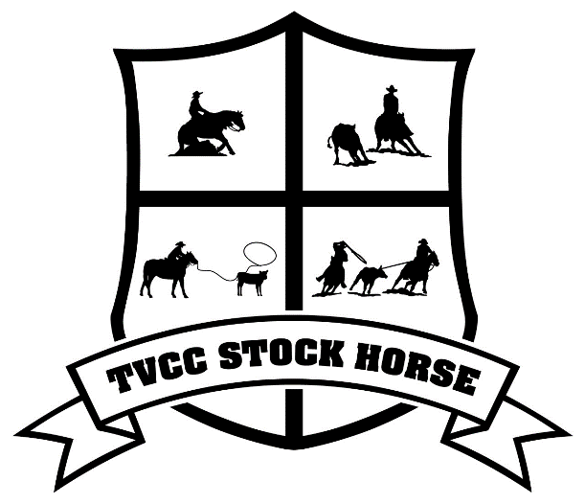
As mentioned earlier I will be sharing my “Pearls of Wisdom” through ranch roping and rodeo parables. It is my prayer that through this bible study you will not only learn to be more productive in your horsemanship, stockmanship, ranch roping and rodeo skills, but that you would grow in your relationship with the Lord as well. I feel that there are five areas that are essential in ranch roping and rodeo, and five areas that are essential in being a child of God. These five areas are: Horsemanship, stockmanship, roping, teamwork, time. During the Fall term we will be focusing on “Time;” during the Winter term, “horsemanship,” “stockmanship,” and “time;” and during the Spring term we will focus on “roping,” “teamwork,” and the “stock dog.” I will also be drawing the correlation between packing and harness training and how they relate to prayer burdens and being equally yoked in marriage. Below is a breakdown of the bible study.
Fall
Horsemanship – “Returning to Eden” personal testimony and horse training philosophy.
Time – War over Reality
Bronc Riding – Strong holds

Winter
Foundation – Who we are in Christ
Stockmanship – Spiritual Discernment
Harness and Packing – Prayer Burdens

Spring
Roping – Spiritual Gifts
Stock Dog – Desire for the Kingdom
Teamwork – Functioning in the Body of Christ
- Driving – Marriage (Being “Equally Yoked”)
- Family – “Training your kids in the way they should go.”
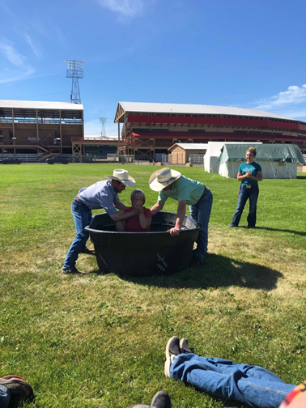
In this Bible study I have compiled 20 years of knowledge of what to do and what not to do in being a child of God. Ty Murray said about one of his books, “This is the book I wish someone would have given me starting out.” Well this is the Bible study that I wish someone would have given me after leaving rodeo Bible camp.

I have struggled with a health condition since I was a junior in high school, and after bouncing back and forth from sickness to health over the last 20 years, I would like to share what I have learned about where sickness comes from and where true healing comes from, for body, soul and spirit.

Although you may have warm fuzzies leaving rodeo Bible camp, once you go home the real battle begins. Why do you think Paul uses the sport analogy and war analogy and stresses proper training to get the prize (2 Timothy 2:3-5, 1 Corinthians 9:24, Philippians 3:14)? Part of the name of this Bible study is “Gideon’s 300” and as a child of God it is important to realize that you are born on a battlefield. After the initial step of salvation, it is imperative that you KNOW who you are in Christ. It is important that you discover what your true profession is as a child of God and are taught how to “put on the full armor of God.” Through the process of learning how to do this you will become Spartans in the Spirit.

Week 2 Online Spartan Clip: “What is your Profession”

I love the lines in this clip.

Arcadian: We heard Sparta was on the warpath, we were eager to join forces.
King Leonidas: If it is blood you seek; you are welcome to join us.
Arcadian: Yet you bring only this handful of forces against Xerces. I see I was wrong to have Sparta’s commitment to at least match our own.
King Leonidas: Doesn’t it?
You there, what is your profession?
Arcadian Soldier: I am a potter, Sir.
King Leonidas: And you Arcadian, what is your profession?
Arcadian Soldier: Sculptor, sir.
King Leonidas: And you?
Arcadian Soldier: I am a blacksmith.
King Leonidas: Spartan’s!!!!! What is your profession?
Spartans: Aahhhooo, Aahhhooo, Aahhhooo.
King Leonidas: See old friend I brought more solders than you.

The Spartans were warriors. They were not like most cultures which had their identity in the world and then left their job to go to war when trouble came. Men in the Spartan culture were in training every day. You could not separate the word Spartan from warrior. If you were a Spartan male, you were a warrior. You were born into a culture of warriors; you were raised and mentored by older warriors, and all your friends wanted to be warriors. Your identity from the time you were born was in training to become a warrior. This training was called “Agoge” and lasted from age 7-20. At age 20, Spartan males became full-time soldiers, and remained on active duty until age 60. Like many great warrior societies (Vikings, Native American, Samurai, Jesus Disciples), Spartans believed that there were great rewards in the afterlife for serving, fighting, and dying in battle. Just as the Spartans entered “Agoge” to be trained to be warriors, our heavenly Father has given us “Agape” (the unconditional love of the Father) as the ultimate training program to produce spiritual warriors.

When we say the name Spartan, we think warrior. What do you think when you say the name Christian? If you were like me a picture of a warrior is not really the first thing that pops into my mind.

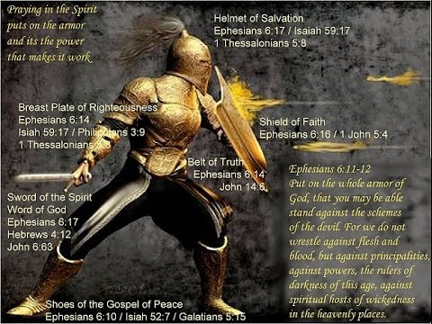

However, Paul uses the war analogy and says this is how we should look as Christians. Although a Spartan may have been born a Spartan, this alone was not enough to produce a Spartan warrior when it was time to join the fighting men at age 20. No, the Spartan kids were born into a Spartan culture and they were taught from a young age (7-20) what it meant to be a Spartan. The young women also went into intensive training as well. They believed that warriors produced warriors and it was important to them that both the men and women had been trained to be warriors. Paul stresses the fact that we are born on a battlefield and it is imperative that we have on the “full armor of God” and are trained for warfare. The question is, are you wearing your armor and more importantly (parents) are you raising your kids with their armor and training them for battle? Well…..it was not just the Spartan parents that produced warriors, it was the Spartan culture that produced the warriors. It is important as parents and soon to be parents that we raise our kids in a warrior culture.

The toughest part in the fight that we are in as Christians is how do you fight a battle that is already won? The war that we are in is not with the enemy because Jesus already defeated him at the cross. The fight, the war that we are in, is learning to REST in the finished work of the cross. I will go into this in much greater detail as the Bible study progresses. However, our war that we fight every day is learning to “walk in the Spirit so that we do not fulfill the lusts of the flesh.” (Galatians 5:16) This will be the pivotal point of this whole Bible study. What does it mean to be “in the Spirit” and “in the Flesh?” Just like sports, it takes “practice” functioning in the Spirit and not falling into the flesh, and just like the Spartan culture, it is important that we are raised in a “Spirit” culture. Just like sports, it is important that we do not develop incorrect muscle memory.

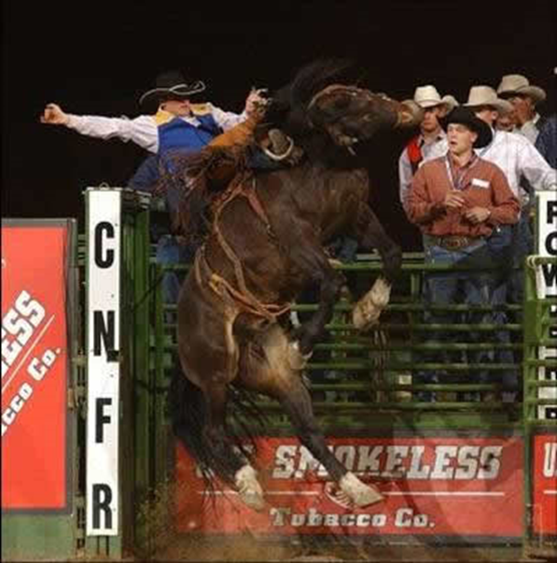
This is why Paul stresses the sport analogy to describe our spiritual walk.

“Do you not know that in a race all the runners run, but only one gets the prize? Everyone who competes in the games goes into strict training. They do it to get a crown that will not last; but we do it to get a crown that will last forever. Therefore, I do not run like a man running aimlessly: I do not fight like a man beating the air. No, I beat my body and make it my slave so that after I have preached to others, I myself will not be disqualified for the prize.”
(1 Corinthians 9:24-27)

Whether we are talking about competing in sports or training to become a soldier, muscle memory is everything. When things get heated in the game, or on the battlefield, a person does not have time to think, they must react, without thinking. This reacting without thinking is called muscle memory and correct muscle memory can only come from intensive training. It is imperative after salvation that we find a training program to help “train us up in the way we should go” (after the Spirit, correct muscle memory), otherwise we will fall into the flesh (incorrect muscle memory) and “depart when we are old.” I pray that this Bible study will help bring together young cowboys and cowgirls who are passionate about growing in their relationship with the Lord and learning correct muscle memory as a “child of God.” Young men and women who are as passionate about their spiritual growth as they are about their horsemanship, stockmanship, ranch roping, showing and rodeo.

