Competing from the
Holy of Holies
Learning to Enjoy the Process of Running an Equine, Ranching or
Rodeo Business without Losing Our Identity in Christ.

Malachi 4:5-6

Proverbs 22:6
“For God did not give us a Spirit of FEAR but of POWER,
LOVE and a SOUND MIND.” (2 Timothy 1:7)

By: Wade Black

Week 3 “Strongholds”

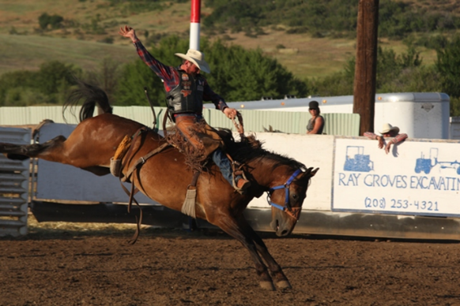
My entire life I have ridden horses. For the last 28 years I have ridden colts, and for the last 18 years I have either been in training to ride broncs, or training others to ride broncs. The most important thing in riding a horse that could possibly buck with you is learning correct muscle memory. The horse is going to act and your split-second reaction to the horse’s action determines whether your butt stays in the saddle, or your head ends up in the dirt. Muscle memory is everything. Often, we make bronc riding too complicated. The bottom line is there are three basic things that a person needs to do to ride broncs. If a person can learn to do these three things successfully, they will have success riding broncs. If you do not, you will get beat up, probably end up hurt, and more than likely quit because you are tired of getting beat up. These three things are lift, charge, and ride your horse. I will break these down further as the Bible study progresses and we discuss “correct muscle memory” and “tearing down strongholds.” It is important to realize that regardless of what horse you have drawn, what level or circuit you are riding in, what bronc saddle you are riding, or what your particular style is, if you do not do these three things you will not be successful.

There are basically three things that a child of God needs to do, and three things a child needs to know, and it doesn’t matter what church you go to, what Bible version you read, or how you worship God. If you do not do these three things you will not be successful. It is also important to point out success in the kingdom looks different than success in the world. “And when he had called the people unto him with his disciples also, he said unto them, ‘Whosoever will come after me, let him deny himself, and take up his cross, and follow me. For whosoever will save his life shall lose it; but whosoever shall lose his life for my sake and the gospel's, the same shall save it. For what shall it profit a man, if he shall gain the whole world, and lose his own soul? Or what shall a man give in exchange for his soul?” (Mark 8:34-37)

Just like it takes a bronc rider his entire bronc riding career to learn how to better “lift on the bronc rein,” “charge to the front end” (setting the feet in the neck), and “ride the horse” (to feel the horse underneath him, get in time and move with the horse, not against the horse); it will take a child of God his entire life to learn these three things. Before I tell you these three things I would like to share with you a little history of how I discovered the three things you need to know and three things you need to do in being a child of God.

Last spring my health was starting to go downhill like it often does during stressful times and has since I was a junior in high school. I was so tired of struggling with health problems, I started to get mad at God. I cried out to God for an answer to why He would not let me just be “healthy” and operate like everyone else. Well, God answered me and basically asked the question, “What does it mean to be healthy?” He began to show me that we are three different parts; body, soul, and spirit and to be truly “healthy” we must give all three parts of our being what they need to survive. In the back of the workbook I have outlined what our body, soul and spirit need in order to be healthy.

SEE “HEALTHY” GRAPH IN THE BACK OF THIS BOOK

Throughout this Bible study I will continually discuss the different parts of the human body and how we encounter the reality of this world and how we encounter the reality of heaven through Jesus. As you can see in this graph, I have outlined the three different parts to the human body and what they need to be healthy. In answer to my question of “Why can’t I just be ‘healthy’ like everyone else?” the Lord so lovingly showed me that it was not my body that was unhealthy it was my soul. It is the sickness in my soul that manifests in my body in the form of Chronic Fatigue Syndrome (first ten years of God’s training, ages 18-28), then oppression leading to depression (second ten years of God’s training, ages 28-38). Oppression is defined as: a sense of being weighed down in body or mind. Depression is defined as: a mood disorder marked especially by sadness, inactivity, difficulty in thinking and concentration, a significant increase or decrease in appetite and time spent sleeping, feelings of dejection and hopelessness, and sometimes suicidal tendencies.

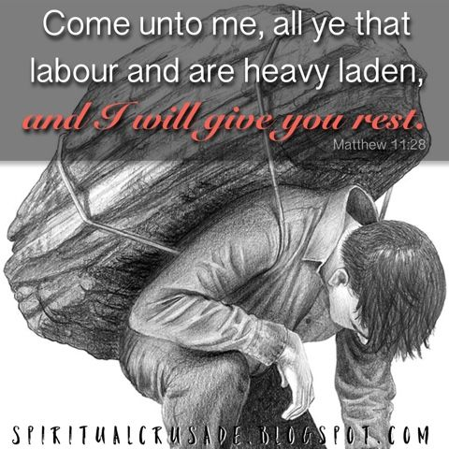
Basically, depression comes in when our body is put in situations in which our soul (mind, will and emotions) is given a weight that is too heavy for the soul to carry. Just as you may physically hurt your back by trying to pack too much weight on your back. We mentally and emotionally hurt our soul when we try to pack to many burdens in our soul. Such a huge part of not letting our soul get weighed down by the things of the world, is making sure that our identity is in Christ (not in the world) and we turn to Jesus when we get weighed down. “Come unto me, all ye that labor and are heavy laden, and I will give you rest. Take my yoke upon you and learn of me; for I am meek and lowly in heart: and ye shall find rest unto your souls. For my yoke is easy, and my burden is light.” (Luke 10:28-30)

The sickness that I think at times is in my body is actually in my soul. This sickness has resulted from trying to meet the three needs of my soul (relationships, job/purpose, and identity/significance) in my relationship with the world through my body, instead of RESTING in my relationship with God through the Spirit. After struggling with sickness for 20 years, my prayer for this Bible study is to help prevent young kids starting out in their relationship with the Lord from sickness in the body and in the soul (mind, will, and emotions).

In the fall section we will be focusing on “the war over reality” and tearing down strongholds. As a born-again child of God, we are in battle. However, our battle is not with flesh and blood, it is with principalities and power of darkness in the heavenly places. (Ephesians 6:12) Our battle, our war that we fight is actually learning to REST in the finished work of the Cross. I have trained intensively in wrestling, football, track, riding broncs, and even managing my own horse training business. However, the most intensive training and the hardest thing I am convinced in this life is learning to REST in the finish work of the Cross and learning to work in this world out of this rest. Learning to work hard in the body and having rest in the soul. The scripture below will be a key concept throughout this entire Bible study and has been an absolute key to my healing in body, soul and spirit.

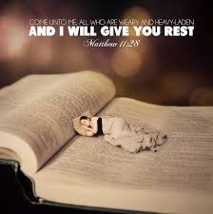
“There remains therefore a rest to the people of God. For he that is entered into his rest, he also has ceased from his own works, as God did from his. Let us labor therefore to enter into that rest, lest any man fall after the same example of unbelief. For the word of God is quick, and powerful, and sharper than any two-edged sword, piercing even to the dividing asunder of soul and spirit, and of the joints and marrow, and is a discerner of the thoughts and intents of the heart.” (Hebrews 4:9-12)

This will be a key concept over the next three terms, “How do you LABOR to enter REST?” I will be going over the below Tabernacle graph and many others as the Bible study progresses. We will break down the pattern of the tabernacle God gave to Moses and how it outlines our spiritual journey to wholeness (gate, altar, laver, lampstand, altar of incense, ark of the covenant) using horse parables.

SEE “TABERNACLE” DIAGRAM IN THE BACK OF THIS BOOK

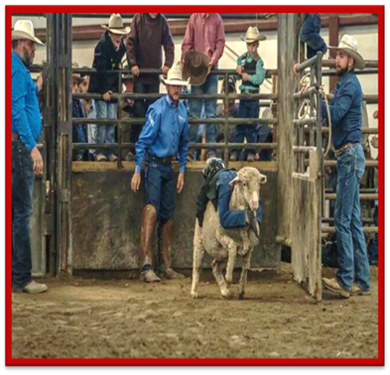
The title of this Bible study is “Gideon’s 300” and the focus is “Training up a child in the way that they should go so that when they are old, they will not depart from it.” As a parent the Lord showed me that there are three things that my kids must know through scripture and through personal experience. The Lord then showed me the degree that my kids do not know and walk in the reality of these truths is the degree that they open themselves up for strongholds. Strongholds are thought patterns that create a reality that is contrary to the knowledge of God (what God thinks). Whether a person is learning to ride broncs, train a wild horse, rope or be disciple of Christ, muscle memory is everything and the focus of a good coach is not letting incorrect muscle memory (strongholds) get started. In all my classes I put together a syllabus and on the syllabus, I have “course outcomes.” The course outcomes for this Bible study are:

(Three things you need to know in being a child of God.)

It is my prayer that students will know through scripture and personal experience:
1) The difference between the old and new covenant.
2) How the gospel sets people free.
3) The power of true worship and the difference between operating in the flesh and in the spirit.

(Three things you need to do in being a child of God.)

After experiencing the previous three course outcomes students will also be able to:
- Love God (Relate to the Father as a child of God, not as an orphan of the
world).
2) Love people (reflect the love of the Father to those around you).
3) Do what God has called you to do (Get an assignment from the Lord and begin taking steps of obedience to fulfill the assignment).

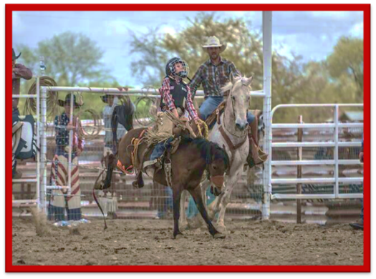
Just like a person needs to understand how to lift and charge to “ride the horse” not fully understanding number 1 and number 3 in the first set of course outcomes has taken me a lot of years to understand number 2, “How the gospel sets people free.” Also, just like riding broncs, the three things that a child of God must do is also a daily struggle. Some days you draw the easy hoppers, get tapped off and things are fun and easy, and other days you draw into the eliminator pen, get the tar beat out of you and it makes you question whether you want to keep entering. My prayer for this Bible study is that you will learn some tips that will help you with your horsemanship, stockmanship, roping, and rodeo skills, but more importantly that through these parables you will have on-going encounters with Jesus and that you will experience the fullness of the gospel. The gospel not only has the power to save your soul for eternity when you die, but to save your body and soul (mind, will and emotions) on a daily basis.

As you watch the bronc rides in the online clip, realize that they did not intend on getting bucked off when they called for the horse and opened the gate. They had a perfect bronc ride pictured in their mind and a solid game plan of lifting, charging, and riding their horse. However, as anyone that has ever ridden rough stock can tell you, although you may have it all planned one way to please the judge, sometimes you get drilled before you even know what happened. As young men and women starting in your relationship with the Lord, you will soon come to find out, it is the same way. However, my idea of a warrior, whether in rough stock, or being a disciple of Christ, is someone that does not quit after getting bucked off. Instead they go back into training (body, soul and spirit) to learn how to better lift, charge, and ride their horse (rodeo), or how to better love God, love people, and fulfill your calling (child of God).

