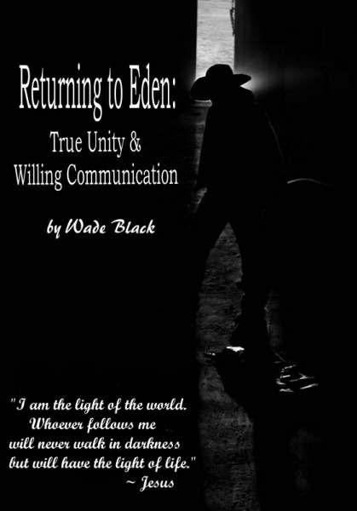

~ Class Lecture: Horse Behavior ~

Traditional Thought Process
Primary Objective: Get horse to do a job
Primary Obstacle: Horse will not do the job
How do I get my horse to do the job?

To eliminate all problems, you will ever have with your horse, change your objective.
Alternative Thought Process
Primary Objective: Horse and Person becoming one; “perfect unity” (Perfection).
-The will of the horse becoming the will of the person: Instead of two forces moving against each other, two forces moving together as one “His legs are my legs, we are one body” (Ray Hunt).

Ray Hunt says, “It’s like a dance. You are leading and the horse following, but you are both moving as one. It’s like a peaceful waltz in perfect unity.” Not a high school, uncoordinated bumpin’, grindin’ hot and sweaty, seizure fit.

*With the second objective you will not have obstacles, because the objective is to eliminate the cause of all obstacles. You are finding a cure instead of treating symptoms.*

*The first measures outward status, to determine progress. In this mind set, perfection is unattainable, and has the potential of creating problems.

*The second deals with inward status to measure progress, this will not cause problems and has the potential of perfection.

My goal for this class has not been to help treat your symptoms, but to help YOU find the cure. THE CURE FOR YOUR HORSE HAS NOTHING TO DO WITH YOUR HORSE AND EVERYTHING TO DO WITH YOU. As soon as a person realizes this, they have taken the first step in becoming a horseman/woman.

Horse’s Will Man’s Will
-3 Primary Driving Factors
1) Survival/ Self-Preservation To do a Job
2) Companionship
3) Comfort
-1 Variable Factor
1) Hormones

Major underlying factors:
- Confidence
- Energy

Confidence
-Confidence is the main underlying factor which drives all three of the primary driving factors.
-A horse will experience comfort when they are confident in a person or situation.
-A horse develops companionship when they are confident in someone or something.
-A horse is driven by self-preservation when they lose confidence in a person or a situation.

Increase in Confidence = Decrease in Self-Preservation (vice versa)
Comfort and Companionship Increase = Increase in Confidence (vice versa)
Comfort and Companionship Increase = Decrease in Self-Preservation (vice versa)

Measures of Confidence Level
- Head height (best measure of confidence level)
  - High = Bothered/Unconfident
  - Low = Relaxed/Confident
- Tail (clamped down/relaxed)
- Eyes (wide-eyed/dopey)
- Movements
  - Tight, stiff, quick movements from fear, braced up = Unconfident
  - Relaxed, free moving (but not scared), supple = Confident

Energy
-Energy is often a major underlying factor of self-preservation, which inhibits the other two driving factors; comfort and companionship.

*As the Energy level decreases ~ Self-Preservation decreases ~ which opens the door to increase Comfort and Companionship (when presented in the correct manner) *

Obstacles in Accomplishing a Job
1st Obstacle – Horse submitting to man’s will.
2nd Obstacle – Communicating man’s will.
3rd Obstacle – Obeying commands.
4th Obstacle – Completing the job.

In order to get a horse to do a job for us, they must first submit their will and accept our will. Then we must try to communicate our will, and finally they will need to obey our commands.

Many people try to overcome the 4th obstacle without paying any attention to the previous three.

Questions to Ask
Does the horse want to do what you are asking?
Does he know how to do what you are asking?

I. 1st Obstacle – Submitting to man’s will
-Two types of Submission
A) Willing
B) Unwilling

-Both are effective to get the job done. However, unwilling has negative consequences.

(A)Unwilling Submission “Giving to Pressure”
- Attained by Force
1) Horse submits because he has no choice.
2) Body submits to will of human, but the mind has not.
3) Horse would rather be somewhere else.
4) Horse becomes a “slave.”
- Rebels if gets a chance.
Ex. Run, buck, brace-up
5) Horse is driven to do job.
6) Horse does the job, but doesn’t like it.
Ex. Tight, head raised, maneuvers have braces

(B) Willing Submission “Seeking Relief”
- Attained by Free Choice
1) The horse chooses to do the job.
2) Set it up so the horse would have it no other way than to do what you want to do.
3) Horses are driven by comfort; make it comfortable to do the job.
“Make wrong hard and the right easy”
4) In this way the horse and person become partners, the horse has a choice.
5) Requires patience, timing and feel.
6) A person can ask a lot more out of a horse once they have submitted willingly.
7) Willingly submitted horses try to please their riders.

Two Levels of Submission & Two Kinds of Horses
I. Ground Level: “Turning to You”
- Our first approach to saddle and ride.
- For them to follow our will, we must meet their driving factors.
- Not be scared of us, “self-preservation”
- Offer them “comfort” and “companionship”
- This can be attained in the pasture and with their buddies. So why do they need us?
- We must develop a need for us in their life.
- This is done by putting pressure on them until they turn to us, and then relieving the pressure.
-As the energy level decreases, self-preservation decreases, opening the door for an increase in comfort and companionship.
- “It takes pressure for relief to be effective and relief for pressure to be effective.” (Martin Black)
- If there is any hope of perfection, this must be attained before we get on them. This is easily achieved in a day.
. A) First Type of Horse: Those that haven’t been handled
- It takes longer to gain trust.
- But relief, comfort, and companionship are much easier to attain.
- Very little pressure has to be applied for them to turn to you for relief (only time).
- No false teachings – usually move off pressure when pressure is applied.

B) Second Type of Horse: Those that have been handled
- Trust, comfort, and companionship have already been established.
- But is very hard to establish the need for you.
- In many cases, a great deal of pressure must be applied for relief to have meaning.
- May have developed false teachings: They lean into pressure when pressure is applied.

II. On Their Back: “Two Becoming One”
- If the first has not been established this is very difficult.
- This type of submission is never ending, until perfection is attained: Until perfect trust, obedience, and communication is established and they never leave your will.
- Achieving perfection: Following submission, there must be a perfect level of communication.

II. 2nd Obstacle – Communicating Man’s Will
- How does man communicate with horse?
We don’t speak the same language, or think the same.
- Non-verbal communication
Ex. Body language, feel
- Communication involves two individuals (two-way communication).
- The person must learn to read the horse. What is the horse saying?
Ex. head raised – bothered, head lowered – relaxed
- We are good about communicating our will to the horse, but do we listen?
- We communicate through their driving factors.
- Self-preservation, comfort, companionship
- A person can get more done with a horse out of trust (comfort, companionship) than out of fear (self-preservation).
- A person must decide in what manner they will communicate with the horse.
- “Slave” or “Partnership”
- “Tell the horse” or “Ask the horse”
- After the first level of submission has been met, the most effective method of communication is through 3 factors.

3 Factors of Communication
1) Feel
2) Timing
3) Balance

*The rate a person is able to move toward perfection entirely rests upon these three factors*

“Feeling” of the Horse
Ray Hunt says, “You can’t buy it and I can’t give it to you.” You can read all the books in the world, have people tell you what “feel” is, see people that ride through “feel,” but you will never have it until you experience it. It can only be achieved between you and the horse. People can help situate you, so that you and the horse are in a position to experience “feel,” but ultimately it is between you and the horse. If you can’t feel when things are perfect, how do you expect to attain perfection?

Often perfection/unity will pass by in a split second and then vanish. A person needs to recognize these split seconds and relieve the applied pressure. It is through receiving relief that the horse develops the desire to stay in perfection. Then the seconds can be multiplied to minutes. A thirty-minute ride with two minutes of perfection is better than a three hour ride with no perfection. The two minutes may be multiplied. However, the three hours without perfection will lead to an unwillingly submitted horse.

4 Types of Horses and Riders
1) No Life, No Direction
2) Life with No Direction
3) No Life and Direction
4) Life with Direction

There are two different factors here, “direction,” and “life.” We run into two problems with our horses; we can’t get them to go on our path, and we can’t get them motivated to go at all. It is easier to get a horse on our path, if they are already moving. The goal is to start slow and build speed. Start simple and get more complicated. Get direction at a walk, then life. Then start putting the two together. Get direction and develop a soft feel at a walk, then get life. Once you have the life then try to direct it. First, just try to go straight in a perfect line; keeping the horse directly between your hands and feet, on a loose rein, no leg pressure, and traveling on the path you have chosen. This is the first step to perfection; life on a straight line. Then gradually start to complicate things and keep the perfection. Start making turns and changing directions, if perfection is lost go straight until it is perfect again; until they are riding perfectly between your hands and feet.

Keep building this confidence, until any path you put them on, they stay perfectly between your hands and feet. Whether it is loping circles, making turns, backing up, tracking cows, any line whether straight, or curved, forward or back, they stay on it. It’s all about life, and direction. It would be scary to try to accomplish our job with all life and no direction, but on the other hand with all direction and no life we would not get anywhere, and our horse would get very sluggish and numb to our cues. We need to find a balance and the goal is always perfection. Whenever perfection is lost, go to a place where it can be attained again. Try to give your horse a job, somewhere to go, something to do. They get bored and numb the longer you stay doing the same thing without giving them something new to work on.

6 Steps in Balancing the Direction to Life Ratio

1) Submit life on ground
- Stand quiet to saddle, bridle, mount
2) Life on ground with saddle
- Loping calm and relaxed with saddle
3) Direction on the ground
- Tipping nose and disengage hindquarters
- Putting slack in the rein when lightly pulled on, breaking in the poll, supple through the loin and neck (giving nose)
- Pivoting around the inside front foot, stopping forward motion (disengaging hindquarters)
4) Direction on their back
- Tip nose, disengage hindquarters, “Doubling” (safety valve)
- standing, walking, trotting, loping
- Putting slack in the rein when pulled on and stopping forward motion pivoting around inside front foot at all four speeds
5) Life on their back
- Loping calm and relaxed with rider
6) Life with direction
- Giving nose and directing hindquarters to stay on a line

(See Solid Foundation of Maneuvers)

III. 3rd Obstacle – Obeying Commands
3 Main reasons horses don’t obey commands
1) Self-Preservation
- Due to lack of trust
2) Disobedience (bitter resistance against commands)
- Due to false teaching (operating through unwilling submission)
3) Lack of Understanding/ Communication
- Horse needs more time, patience, and teaching

- A person must learn to distinguish between the three, if they are ever to become a good horseman/woman
- A person must learn to read the horse to determine why the horse is not obeying
- This is crucial because the person’s reaction for the horse’s action, will greatly impact the horse’s mind set and overall trust for the person

- Resistance arises as a result of these three factors
- As resistance level rises, self-preservation rises (Fight or Flight)
- The resistance level of the horse is a direct result of the amount of pressure put on by the person

Resistance in Obeying Commands
#1 Reason = Horse hasn’t submitted to man’s will

3 Stages of Resistance
1) Disagreement
- Good; builds trust
- Horse builds confidence in your decisions
- Horse needs to learn that your decisions are always right. Be consistent.
- It is always easier to obey your commands.
- Person always has best interests in mind for horse.
- Don’t give him more than he can handle.

2) Arguing
- Most often a result of false teaching, (operating through unwilling submission)
- Heated disagreement
- Needed but not always necessary
- Arguing is needed during disobedience
- Disobedient horse needs to run into authority
- Be careful pushing arguments into a fight

3) Fighting
- Almost always because of false teaching
- In confused and scared horses, this is caused by impatience of the person.
- Fights are not good, but are needed for some horses (disobedient/ spoiled horses)
- A horse will always win a fight against a man
- They are bigger and stronger
- Do not fight with a horse, let them fight against themselves.
Ex. Tie their head solid, tie a leg up, rope a hind leg with another horse or tie a leg back, set your hands solid on their neck (collecting).
- Some spoiled and disobedient horses must go through a good fight before they can
willingly obey commands.
- Make sure that when they are done fighting against themselves, you are there to offer them a better, more comfortable way.

Example
To better explain the different levels of resistance, I will give an example of trying to get a horse to give their nose. An example of agreement would be as soon as the slack is taken out of the rein, applying pressure to the horse’s mouth, the horse seeks relief by breaking at the poll, softens through the loin, and willingly tips his nose, putting slack in the rein.

Disagreement – When the slack is taken out of the rein, the horse hesitates, the person has to wait for the horse to give his nose and put slack into the rein. (Usually driven by lack of communication.)

Solution – Patience, wait for the horse to give. Moving the horse’s hindquarters, putting life in the feet may help to put slack in the rein. As soon as the horse puts slack in the rein, relieve pressure.

Argument – When the slack is taken out of the rein, the horse’s head comes up, causing the horse to be stiff through the poll, neck and back. (Usually driven by lack of communication or self-preservation.)
Solution - Slow down and lighten the pressure until the horse’s head comes down, then wait for the horse to give.

Fighting – When slack is taken out of the rein, the horse flips or shakes his head. (Usually driven by resentment.)

Solution – NOT GOOD! It is easier for horses with bad teeth to become resentful to pressure on the bit (get your horse’s teeth checked). However, whether bad teeth or not, it is always because of too much pressure applied. This is not an easy problem to fix, because the horse is no longer driven by confusion or self-preservation, but by resentment. It is far better to never let it get this far. For best results I set my hands on the horse’s neck and apply light pressure getting the horse to flex in the poll. (This may take a while, because the horse is resentful to pressure and will try to root against the bit or flip their head.) Be patient, once they have learned to give to pressure and relax flexing in the poll, then I lightly try to get them to tip their nose, and break the hindquarters. Look for the “smallest change and the slightest try” when your hands are set. As soon as they give, give them relief.

The man and horse relationship is similar to the relationships we have with people. The level of our relationship is based on the amount of agreement we have. If we agree on the big things (willing submission), the little things (obey commands) will most often fall into place. However, if there is no agreement on the large issues, although we may have come to agreement on some smaller issues, when our relationship is put to the test, it will fall apart.

Because horses are prey animals, trust is the main issue. We must gain trust on the ground, on their back standing, walking, trotting, loping, and galloping. If speed exceeds confidence, the trust that was previously established most often is lost and must be re-established. Horses are very forgiving and with time will learn to trust us again. However, similar to us, we can only shatter that trust so many times before they learn that we are not trustworthy. The amount of time the horse was ridden after losing confidence, will determine how long it will take to build confidence and gain trust again. Some horses with a history of riding without confidence will never fully be able to trust.

A horse is going to have to run into some resistance from time to time, until our will for the horse, has become the horse’s will. However, make sure that your relationship is based on agreements and not on disagreements, arguments, or fights. If the man and horse are not operating in agreement, it is either because of false teachings or poor communication by the human.

IV. 4th Obstacle – Completing the Job
Resistance is what keeps us from completing the job*

4 Things Need To Be Established To Prevent Resistance:
A) Willing Submission
B) Good Communication
C) Solid Foundation of Maneuvers
- Head and Neck
- Shoulders
- Hindquarters
D) Balanced direction to life ratio

Solid foundation of Maneuvers
1) Head and Neck -direction
a) Horizontal flexion- Loin and Poll (Axis Vertebrae)
When slack in taken out of one rein, the horse puts slack back into the rein
(Willing submission). Horse “gives” to the right and left bringing their head
around to the stirrup on a loose rein, breaking in the poll, with suppleness
through the loin and neck. This should be achieved standing still and with forward motion. Horse should “give” his nose; standing, walking, trotting, loping and galloping.

b) Vertical flexion- Loin and Poll (Atlas Vertebrae)
When the slack is taken out of both reins, the horse breaks in the poll willingly putting
slack back into the reins. This should be achieved; standing, walking, trotting, loping
and galloping.

*The horses head is directed with the reins. When the slack is taken out of the reins if the horse does not put slack back into the reins, the horse is being ridden in un-willing submission/false teaching (wearing pressure instead of giving to pressure)*

2) Shoulders -life and direction
- When lightly asked with our legs, the horse should willingly and immediately
bring life to their front feet in the direction we have shown them.
Life- Walking, trotting, loping, galloping
Direction- Forward, backward, laterally

3) Hindquarters -life and direction
- When lightly asked with our legs, the horse should willingly and immediately
bring life to their hind feet in the direction we have shown them.
Life- Walking, trotting, loping, galloping
Direction- Forward, backward, laterally

*The horse’s feet are directed by both our reins and our legs. Our reins only show them where to go, our feet get them there. Our reins are the stirring wheel which tells our horses where to go; our legs are the gas pedals which brings life to the direction enabling them to move willingly. If we show them where to go with our reins and they do not move, they most often need more life, not direction. If they do not receive the needed life to help direct the feet, but instead receive more direction from the reins, they will often become resentful to the direction by; elevating, flipping, shaking their head, or rooting their nose against the bit. Or they will become numb and dull. All are a form of un-willing submission.

The horse needs to be able to give his nose at different speeds, being supple through the loin, poll and neck. However, the reins need to be tied to the feet. Where their nose is tipped, the feet must follow.

4 Stages of Setting a Foundation – “Solid Foundation of Maneuvers”

- Stage 1 – Submitting Hindquarters.
- Lateral movement of the hindquarters. Stopping forward motion pivoting the hindquarters around the inside front foot. Walking, trotting, loping, galloping

Ex. – Doubling to the left – Tip nose to the left pulling out (not back) at a 90 degree angle from the eye (rein should not be longer than a foot). Right rein should be long enough that the horse can bring his nose all the way to your left stirrup and still have a float in the right rein. Your inside shoulder should be higher, have more weight on right butt cheek and your head should be slightly tipped to the right side of the horse’s neck. Bring left leg into the horse’s left side to direct the hindquarters to the right.

Goal – When forward motion stops the horse will stop driving with the hindquarters and pulling with the front end. The horse will “disengage” the hindquarters stopping the driving motion. The front left leg will change from a forward motion “leaning” to the left, to “pushing” the hindquarters around the left front leg using centrifugal force. When this happens the horse will put slack in the rein bringing their head and neck to the left, arching their ribs to the right and pushing the hind end to the right around the left front foot. They should accomplish this in less than three steps from the time you take the slack out of the rein. If they can not do it in less than three steps in a walk, do not try to do it in a trot and lope.

We may have to sacrifice the head to get the feet sometimes. Like flagging a horse tied to a post, they may hit the end of the rope and raise their head before they disengage their hindquarters. When the feet get right, it will be easier for the head to get right. After a horse hits the end of the firm lead rope a few times they then start preparing to move their feet before the slack is taken all the way out of the rein. Apply the same concept to your horse when getting them to pivot around the inside front foot. However, always come back and make sure they are soft in the face “giving” their nose. Always remember to keep the direction (head and neck) to life (feet) ratio balanced.

3) Stage 3 – Hindquarters and Shoulders
- Lateral movement of both the shoulders and hindquarters in a forward motion crossing the feet (leg yield, side pass). Walking and trotting.
Ex. – Lateral movement to the right – When a horse becomes solid in Stage 1, when we put our left foot into them and tip their nose to the left they should immediately swing their hindquarters to the right. Then all we have to do is draw on the outside rein (right) and get forward motion. The easiest way to start is to ride parallel with the fence, then swing the hindquarters out so that the horse is at a 45-degree angle with the fence. If the horse stays at a 45-degree angle with forward motion he will cross over in front. When the horse crosses its front feet relieve the pressure. Be sure to block the horse with your outside right rein when you kick the hindquarters out. If you do not, the horse will go past the 45-degree angle with the fence, to a 90-degree angle and then it is impossible to have forward motion and cross over in front.

Goal – When we fan our left leg the horse should immediately step laterally to the right with forward motion crossing the front feet. If he does not, go back to step 1 and get his hindquarters moving off your leg again and then come back to the shoulders. The end result should be walking and trotting in a straight line and when we lightly fan our left leg the horse moves in a lateral motion crossing the front feet to the right.

4) Stage 4 – Shoulders
- Lateral movement of shoulders. Stopping forward motion pivoting the shoulders around the inside hind foot.
Ex. – If the horse is solid in Stage 2 in that when we fan our outside leg they cross their front feet we only have to do two things: 1) walk the front end around the hind end, and 2) teach the horse to pull with their inside hind foot (centrifugal force). Do not start by trying to do a full circle, do quarter and half turns. After you make part of a turn (walking the front end around the hind end) hustle the horse out of the turn. If the horse knows he has to hustle out of the turn, he will start pulling himself through the turn so that he can have a quicker departure. This will cause him to pull with the inside hind foot using centrifugal force to run the front end around the hind end. Make sure that your weight is on the outside of the turn. Our weight will either help the horse in the turn, or hurt the horse in the turn; there is not much middle ground.

Goal – There are two fundamental things that have really limited my ability in turning a horse around. The goal is to try not to do these two things; remember willing submission, good communication, and keeping the direction to life ratio balanced. Then we will be on the right track to getting a horse to turn around.

1) Not having a SOLID foundation in step 2 results in kicking through the turn.
The horse must willingly and comfortably move off our legs in a lateral motion crossing their front feet. If we have to use a spur to get the horse to move their shoulders in a turn, this will cause the horse to: arch their ribs to the inside of the turn instead of the outside, throw their head up, and become tight and stiff. They must move off our leg relaxed and comfortably. They must move off our leg. “Seeking relief, not giving to pressure.”

2) Pulling through the turn. (Too much direction, not enough life)
We must remember that we are trying to walk the shoulders around the hindquarters. If we try to pull the shoulders around the hindquarters using our inside rein this will cause them to swing the hindquarters out. “Our reins show them where to go and our feet get them there.” Show them where to go with your reins and if they do not move, then use your feet to move the shoulders around the hindquarters; do not pull harder. Keep the head straight or slightly tipped to the inside. If the horse’s head gets ahead of his feet, bring the life up bringing his shoulders back in line with his head. (Direction to life ratio.)

If you want to speed the horse up in a turn, don’t pull harder with the reins or kick harder with the outside leg. Get more life with forward motion crossing the front feet (Stage 2) and then bring the life back into the turn, using centrifugal force to pull the front end around the hind end (Stage 3). If your horse is not immediately moving off your legs laterally when pressure is applied, then return to (Stage 1) and “apply pressure until relief has meaning” and they begin to willingly move off your legs.

Key concept
*Centrifugal force (using the inside hind foot to pull the shoulders around the turn) is a very important concept in making a good turn.

The rate at which a horse is able to progress is determined by the horse’s ability to stay on a set line and speed; whether it is straight or curved, walking or running. When a horse travels off that line, we need to be able to direct and move them back on line. When the nose is tipped the feet should follow. After the nose is tipped, if the feet continue to push in the same direction, the method of realignment is determined by what stage the horse is in. The method of realigning the horse is either by moving the hindquarters (Stage 1) or shoulders (Stage 3). If the horse has not become solid in Stage 2, do not try to jump to Stage 3 to realign the horse.

Common Mistake
When a horse in Stage 1 or 2 gets off line (loping circles), the person tries to push the shoulders over to get them back on line. Once the horse begins to push to the outside of the circle, the person looks at the horse’s head, shifting their weight to the inside to be able to kick the horse better with the outside leg. This causes the horse to push out even harder to the outside of the circle. The person then kicks and pulls harder to keep the horse loping, trying to pull them back on line. As the pressure increases from the rider, the horse’s resistance level rises due to self-preservation and lack of communication. If pushed far enough, the horse eventually pulls their head straight and runs off.

Proper Solution
As a horse in Stage 1 or 2 starts to push to the outside of the circle, shorten the inside rein, shift weight to the outside, use inside leg, and look behind you to the outside of the circle (this will shift your weight, help block the shoulder and lets the horse know where you are going). Horses can feel where a person is looking. Ride where you want to go.

Preventative Maintenance
Don’t set negative patterns in your horse. If he leans the first time around in your circle, head it off the next time. Shorten your rein and lean to the outside before he starts to lean out in your circle. Do not continually try to lope to complete the circle once the horse has become stiff and starts to push to the outside; this will set a negative pattern. Slow down to a trot if you need to and take the lean out: 1) Kick the hindquarters out; 2) Move shoulders over (if they are at the proper stage); 3) Cut the circle in half. By cutting the circle in half, it will over-compensate for the horse pushing. In the spot where the horse was previously leaning, he will then be thinking about getting to the other side of the circle and will not lean. Once the horse has begun to think about getting to the other side of the circle, instead of pushing out; then try to complete a full circle.

4) Circle to the inside or ride them higher. If the horse cuts in at the top the circle going to the left take the horse in a little circle to the left. (He will more than likely being leaning to the right at the bottom of your circle.) Give the horse his head and kick him with both feet shooting him out of the circle “riding higher” right at the point when he will no longer lean to the right and before he cuts into the left. Kicking him with both legs will bring his head straight and will shoot him higher on your circle. A person might have to take a few circles but the horse will learn it is more work on the inside of the circle, than on the outside and will quit leaning in.

5) Loping circles in a field. This is the most effective way I have found of getting a horse to lope nice circles. A plowed field with deep ground works the best. Try to lope a circle and whenever your horse cuts in ride him straight until the lean comes out and whenever he leans out double him. Disengage the hindquarters stopping the front end, and then push your horse across through the other side of the circle and lope straight for a ways. Then try to make another circle.

3 Stages of Breaking a Horse
I. Setting foundation
II. Using jobs to build foundation
III. Taking Foundation to do a job
IV. Maintaining the foundation

- Neglecting the foundation to get a job done is the cause of many problems.
- The job becomes more important (sorting cows, loping circles, opening a gate) than building the foundation. They complete the job, but at the expense of weakening the foundation.
- By thinking only about the job, negative patterns are set, and the horse learns to operate through unwilling submission.
- An ounce of prevention is worth a pound of cure: Do not let negative patterns form.

If good communication, willing submission, and a solid foundation of maneuvers have been established, the person is on the right path for perfection. Most of the problems we have with our horses result from a lack of confidence in one of these areas. All hope of perfection leaves when willing submission is lost. Once the person tries to force the horse into operating through unwilling submission, the perfection that was previously established slowly starts to diminish.

I have never achieved total perfection in any of my horses. However, there have been times when I have felt perfection while I was riding. It is by “feeling” these times of perfection and multiplying them, that I believe perfection is attainable. I don’t know if I will ever attain total perfection with my horses, but I know that it is attainable. I think the amount of perfection that can be experienced, is entirely up to the person and how much time they are willing to work on it. Perfection does certainly not need to be attained to enjoy riding a horse. However, for me, the more times of perfection I have when I am riding, the more enjoyment I receive. My livelihood revolves around horses, if I am not improving I get bored and riding colts becomes work. The times I have improved the most with my horses, have been when I have been aware of the times of perfection during a ride and tried to multiply them.

~Two Thought Processes~

As I have said earlier, I wrote this book seven years ago (from 18-25) as the Lord began to teach me through horses how to eliminate the resistance from walking in the fullness of the gospel. Fourteen years later, although I have definitely gone through some serious fires since the writing of this book, the message is still the same. We can “Return to Eden” and experience “True Unity and Willing Communication” with the maker of the universe. As I have said and will continue to stress throughout this entire book, within these pages is a reflection of my relationship with my precious Lord and savior. If there is something that you can take to help build a better relationship with your horse and more importantly the Lord that is awesome. However, I am not trying to force you to believe what I have experienced through MY relationship with my Lord and the Savior of my body, soul (mind, will, emotions) and spirit as He has revealed himself to me through scripture. No more than I can try to tell one of my students the only way to ride a bronc, or start a colt, is what I have learned through my experience. I have experienced the reality of starting colts for the public for twenty years, riding broncs for ten years and seeking God for 16 years to experience the fullness of the gospel and the new covenant. I have sought Him with the intent to have Him TOTALLY heal my body and soul (mind, will and emotions) from a sickness I received my junior year in high school that effects my physical strength and mental clarity. He has taught and continues to teach me through horse parables how to receive this healing through the process of denying the flesh and learning to live in the Spirit. Like I have said and will continue to say throughout this book, eat the meat and throw out the bone. (Written 2015)

Traditional Thought Process (will be referred to as Traditional)

Primary Objective: Get horse to do a job Primary Obstacle: Horse will not do the job. How do I get my horse to do the job?

*To eliminate all problems you will ever have with your horse, change your objective. *

Alternative Thought Process (Will be referred to as Alternative)
Primary Objective: Horse and person becoming one, ―perfect unity.

- The will of the horse becoming the will of the person. Instead of two forces moving against each other, two forces move together as one. ―His legs are my legs, we are one body (Ray Hunt). Ray Hunt says, ―It‘s like a dance. You are leading and the horse following, but you are both moving as one.

With the Alternative you will not have obstacles, because the objective is to eliminate the cause of all obstacles. You are finding a cure instead of treating symptoms. The Traditional measures outward status to determine progress. In this mind set, perfection is unattainable, and has the potential of creating problems. The Alternative deals with inward status to measure progress. This will not cause problems and has the potential of experiencing perfection.

The primary difference between the two thought processes is perfection. The goal of one is perfection (two becoming one) and the goal of the other is job completion. Here is the question. Is perfection/true unity attainable? Can it be experienced with our horse? Can it be experienced in our life? Or are we striving for something that is unattainable? The rest of this book hinges around this question. Tom believed in perfection and he strived to achieve it with every horse. Tom tried to get others to ―feel this perfect unity and to help them reach it. Although not many did, this was the goal.

The Greek word for perfect is teleios and means; Complete (in various applications of labor, growth, mental, and moral character) completeness. Just like Adam was in the beginning; through Jesus washing us of all our sin, we can enter back into the completeness Adam experienced before the fall of mankind. We can return to total completeness in mental and moral character (body, soul {mind, will, emotions} and spirit (relationship with God: Father, Son and Holy Spirit). ―Till we all come in the unity of the faith, and of the knowledge of the Son of God, unto a perfect man, unto the measure of the stature of the fullness of Christ. (Ephesians 4:13).

However, this perfection/completeness is just like training a horse. Although the horse may encounter a breakthrough in the round pen and learn to get out of their self-preservation and look to us for comfort and companionship for that day. They are a long way from being perfect (mature, complete) in us. They are a long way from their soul (mind, will and emotions) being entirely in line with us to do the job/jobs we have predestined them to do with us. It is the same with the Lord. Although I may have asked the Lord into my heart at eight years old and fully gave Him my life at a rodeo bible camp at sixteen to be used to build His kingdom. It has been and continues to be a PROCESS of letting the Holy Spirit train my soul (mind, will and emotions) through scripture, to come in line with the Fathers. This is what it means to be mature/perfect/complete “in” Christ. When I am “in” Christ and the Holy Spirit is influencing my heart to be in line with Jesus’ heart and I want what Jesus wanted when He walked this earth, my body feels healthy/ complete “in” Him. When I am “in” Christ and the Holy Spirit is influencing my mind to be in line with Jesus’ mind and I think how Jesus thought when He walked this earth, my body feels healthy/ complete “in”. When I am “in” Christ and the Holy Spirit is influencing my emotions to be in line with Jesus and I feel what Jesus felt for people when He walked this earth, my body feels healthy/ complete “in” Him. However, just like a horse when I begin to seek (heart, will) comfort out of my Master and Trainers will, my mind and body do not operate properly which in turn produces negative emotions. The reality of this concept and breaking down body, soul, spirit and the reality in which I have walked since my junior year in high school can be found in this graph “Who am I? What do I want? What is driving my actions”? This is something that I look at every day to determine which reality I want to walk in for that day (Written in 2015).

God believes in perfection/completeness, and that is why He sent His Son to live inside us, to complete us. The Spirit of Christ lives within us, ―Don't you know that you yourselves are God's temple and that God's Spirit lives in you? (1 Corinthians 3:16), and it is through Him (not us) that we can be totally complete. There is nothing we can do within ourselves to experience this perfection, perfection comes only from us getting out of the way and letting Jesus live through us. Just like Ray Hunt says, he is a part of the horse and they are moving together as one. The same completeness is available, as we decrease and Christ is formed within us. ―I in them, and thou in me, that they may be made perfect in one; and that the world may know that thou hast sent me, and hast loved them, as thou hast loved me (John 17:23). As we begin to get out of the way (our fleshly nature/ self-preservation) we begin to look like Christ and act like Christ, until we no longer find ourselves falling into sin (the old man/ self-preservation). This is the goal in our spiritual walk. “I am crucified with Christ: nevertheless I live; yet not I, but Christ lives in me: and the life which I now live in the flesh I live by the faith of the Son of God, who loved me, and gave himself for me. (Galatians 2:20)”

In Philippians 3:12-15 Paul says, ―Not that I have already attained this, or have already been made perfect, but I press on to take hold of that for which Christ Jesus took hold of me. Brothers I do not consider myself to have taken hold of it. But one thing I do: Forgetting what is behind and straining on what is ahead, I press on toward the goal to win the prize for which God has called me heavenward in Christ Jesus. (NIV) Let us therefore as many as be perfect be thus minded: and if in anything you be otherwise minded God shall reveal even this unto you. (KJV)‖

The level of unity that can be experienced, with a horse and with God, is entirely up to each individual and how much we are willing to die to ourselves ―I die daily (1 Corinthians 15:31). It is a matter of getting out of our self-preservation (thoughts involving I, me, we, us), so the completeness of Christ can live in and through us. Just like with the horse it takes lots of time and lots of patience. ―But let patience have her perfect work, that ye may be perfect and entire, wanting nothing (James 1:4-5). I believe that perfection/completeness in Christ is attainable and we can live in the perfect/complete will of God. ―And be not conformed to this world: but be ye transformed by the renewing of your mind, that ye may prove what is good, and acceptable, and perfect, will of God (Romans 12:2). I believe in the Bible and the Bible tells me there is perfection/completeness ― “in” Christ Jesus ―Whom we preach, warning every man, and teaching every man in all wisdom; that we may present every man perfect in Christ Jesus‖ (Colossians 1:28).

George Fox (1624-1691), the founder of the Quaker church and an amazing man of God, said in his journal, ―In all the sects of Christendom (so called) I found none to be told that they should ever come into the state of Adam‘s perfection. The state in which Adam was in before he fell. Fox suffered many beatings at the hands of so called Christians and was not accepted by the church. What was it that he said that enraged the early church? He said they could return to the state they were in before the fall, return to perfection, enter back into a close, intimate relationship with God here on earth.

―Moreover the Lord God let me see, when I was brought up onto this image in righteousness and holiness, and into the paradise of God, the state how Adam was made a living soul, and also the stature of Christ, the mystery, that had been hid from ages and generations, which things are hard to be uttered and cannot be borne by many. For, of all the sects in Christendom (so called) that I discoursed withal, I found none that could bear to be told that any should come to Adam’s perfection, into that image of God and righteousness and holiness that Adam was in before he fell, to be so clear and pure without sin, as he was. Therefore, how should they be able to bear being told that nay should grow up to the measure of the stature of the fullness of Christ, when they cannot bear to hear that any should come, whilst upon earth, into the same power and Spirit that the prophets and apostles were in? Though it be a certain truth, that none can understand their writings aright without the same Spirit by which they were written (Fox, 1997).

I do not understand how Christian churches do not believe and preach the full gospel which is perfection/completeness through Christ in (body, soul, spirit). This is what Christ died for, ―Knowing this, that our old man (self-preservation/flesh) is crucified with him, that the body of sin might be destroyed, that henceforth we should not serve sin. For he that is dead is freed from sin. Now if we be dead with Christ, we believe that we shall also live with him: Knowing that Christ being raised from the dead dies no more; death hath no more dominion over him. For in that he died, he died unto sin once: but in that he lives, he lives unto God. Likewise reckon ye also yourselves to be dead indeed unto sin (self-preservation), but alive unto God through Jesus Christ our Lord
(Romans 6:6-11 KJV).

Through Jesus Christ we no longer have to live in our ―old man (imperfection). We can live ―in Christ Jesus (perfection/completeness). ―There is therefore now no condemnation to them which are in Christ Jesus, who walk not after the flesh (old man), but after the Spirit (Romans 8:1 KJV). Jesus died to restore that which was taken. What was taken? Perfection/completeness with God. ―Whom we preach, warning every man, and teaching every man in all wisdom; that we may present every man perfect in Christ Jesus‖ (Colossians 1:28).

Under the old covenant perfection/completeness was never attainable. ―For the law having a shadow of good things to come and not the very image of the things can never with those sacrifices which they offered year by year continually make the comers thereunto perfect (Hebrews 10:1). ―For the law made nothing perfect, but the bringing in of a better hope did: by which we draw near to God. (Hebrews 7:19). Under the new covenant we have free access to God in the Holy of Holies where we can experience the Glory of God and be transformed into the image of Jesus Christ. ―But we all, with open face beholding as in a glass the glory of the Lord are changed (Greek-transformed) into the same image from glory to glory even as by the Spirit of the Lord (2 Corinthians 3:18). This is huge people!!! I will explain the old and new covenant in greater detail in a few chapters, but just know that under the old covenant perfection/completeness was unattainable, but thank you Jesus, under the new covenant it is! Think about that scripture in 2 Corinthians 3:18 that is one of my favorite scriptures in the entire bible.

Jesus is perfect, we are imperfect; however, by spending time ―in His presence ―in the glory of the most High God, we can be transformed into His image. How great is that! We have free access to God where we can be transformed into His image; all we have to do is come to Him. Not that we ever become God, but that through submitting ourselves to Christ the Spirit of Christ can live through us. ―But ye are come unto mount Zion and unto the heavenly Jerusalem, and to an innumerable company of angels. To the general assembly and church of the firstborn, which are written in heaven and to God the judge of all, and to the spirits of just men made perfect, and to Jesus the mediator of the New Covenant, and to the blood of sprinkling, that speaks better things than that of Abel. (Hebrews 12:22-24). All we have to do is come to Jesus and let Him transform or imperfections (mind, body and spirit) into the perfection that is found ―in and only ―in Him. Just like the women with the issue of blood that said, ―If I may but touch His cloths, I shall be made whole (Mark 5:28). What we have to do is press through the crowds of the world (religion, work, pride, money) and touch the robe of God.

If we are transformed into the image of Jesus from Glory to Glory (2 Corinthians 3:18); Jesus did not have any sickness or disease, Jesus didn’t have any imperfections in His mind, body, or spirit. Thank you, Jesus, that we can be transformed into your image: mind ―we have the mind of Christ (Corinthians 2:16), body ―now he himself bore our sin in his body…by his stripes we are healed (1 Peter 2:24), (Romans 8:11), spirit ―For ye have not received
the spirit of bondage again to fear, but ye have received the Spirit of adoption, whereby we cry, Abba, Father. (Romans 8:15). He was perfect in every way and this is what is available to anyone that would take up their cross and follow him. ―And he that taketh not his cross, and follows after me is not worthy of me (Matthew 10:28).

Why can’t the church bear to be told they can reach the state Adam was in before the fall, the state that Christ Jesus shed his precious blood for? “For since by man came death, by man came also the resurrection of the dead. For as in Adam all die, even so in Christ shall all be made alive (1 Corinthians 15:21-22)”. The reason is they are not being taught by God, but by man. Being made perfect (complete) in Christ is only attainable through Christ Jesus, not by religion and not by works! ―Howbeit we speak wisdom among them that are perfect: yet not the wisdom of this world, nor the princes of this world, that come to nought: But we speak the wisdom of God in a mystery, even a hidden wisdom, which God ordained before the world unto our glory. (1 Corinthians 2:6). Perfection could NEVER come from man, but only from God; Father, Son and Holy Spirit, the Trinity. ―Be ye therefore perfect even as your Father in heaven is perfect (Matthew 5:48). Jesus was the example and He does want us to follow Him. ―The disciple is not above his master: but everyone that is perfect shall be as his master (Luke 6:40).

Fox told the people that God did not dwell in temples made with hands, that we were the temple of God and that Christ was within us, ―Don't you know that you yourselves are God's temple and that God's Spirit lives in you? (1 Corinthians 3:16). He tried to get the people to listen to the Holy Spirit and let them be taught by God. Fox tried to reach the church, but after suffering beatings, imprisonments, and many hardships, he was only able to reach a small number. Fox was not dealing with children that wanted to know their Father. He was dealing with adults who had been taught by man and felt they could gain maturity in Christ through the church and its theology.

George Fox wrote, ―Now I was come up in spirit through the flaming sword into the paradise of God. All things were new, and all the creation gave another smell into me than before, beyond what words can utter. I knew nothing but pureness, and innocence, and righteousness, being renewed up into the image of God by Christ Jesus, so that I say I was come up to the state of Adam which he was in before he fell. The creation was opened to me, and it was showed me how all things had their names given them according to their nature and virtue. And I was at a stand in my mind whether I should practice physic for the good of mankind, seeing the nature and virtues of the creatures were so opened to me by the Lord. But I was immediately taken up in spirit, to see into another or more steadfast state than Adam’s in innocence, even into a state in Christ Jesus that should never fall. And the Lord showed me that such as were faithful to him in the power and light of Christ, should come up into that state in which Adam was before he fell, in which the admirable works of the creation, and the virtues thereof, may be known, through the opening of that divine Word of wisdom and power by which they were made.

This is basically the pivot point of the two thought processes: those that believe there is perfection (completeness) ―in Christ Jesus and are willing to die to themselves to experience it, and those that do not believe perfection can be experienced through CHRIST and are not willing to get out of their self-preservation (flesh) to experience it. I think this is why in the bible and still today it is so easy for sick and diseased (mentally and physically) people to experience the fullness of gospel. When person is living this life with a body or mind that is not working properly and the FULL gospel is preached, like the women with the issue of blood we are willing to do whatever it takes to experience it. When your body and mind is sick you do not have the energy to seek Him with your mind, and are only left to seek Him with your broken heart. “The LORD is nigh unto them that are of a broken heart; and saves such as be of a contrite spirit. (Psalm 34:18)”

Are ye so foolish? Having begun in the spirit are ye now made perfect in the flesh? (Galatians 3:3). Paul had not received total perfection/completeness in Philippians 3, but he was striving for it. Paul knew that he was imperfect within himself in Romans 7 and could not follow Gods commands. That’s why in Romans 8 he tells us of a better way. He says there is no condemnation for those who are in Christ Jesus, ―Therefore; there is now no condemnation for those who are in Christ Jesus, who walk not after the flesh but after the Spirit (Romans 8:1). There is perfection/completeness in Christ Jesus, ―Whom we preach warning every man, and teaching every man in all wisdom; that we may present every man perfect in Christ Jesus‖ (Colossians 1:28). Paul believed and had experienced perfection in Christ. He knew he was perfect in Christ. Tom also believed in perfection, and he worked to achieve this in his horses. The two thought processes determine what type of submission we will enter into: willing ―seeking relief, or unwilling ―giving to pressure. Our choice is whether we want to strive for perfection in Christ, or focus on job completion. The same is true with our horse.

Striving For Perfection/ Completeness– Evidence from Scripture

If anyone wants to know what I believe on any topic relating to doctrine and theology, or anything for that matter, I believe God’s word. I believe the word of God and I believe His word can set us free from any and every problem in this life. ―And you shall know the truth and the truth shall make you free. (John 8:32). What saddens me is God’s word is not setting ALL of His children free. What saddens me terribly is that sometimes the bible actually divides His children. This should not be! However, with the 100‘s of different translations I think God’s word has gotten watered down in some of the translations. Just be careful, ―For I testify unto every man that hears the words of the prophecy of this book. If any man shall add unto these things, God shall add unto him plagues that are written in this book: And if any man shall take away from the words of the book of this prophecy, God shall take away his part out of the book of life, and out the holy city, and from the things which are written in this book (Revelations 22:18, 19).

Make sure you are truly reading God’s word and not someone else’s translation of what they think God’s word was trying to say. God’s word should not divide His children, but unite His children. Show me division somewhere among God’s children and I will show you a group of people that are not hearing God’s word. ―In them is fulfilled the prophecy of Isaiah: You will be ever hearing but never understanding. You will be ever seeing but never perceiving. For this people’s heart has become calloused they hardly hear with their ears, and they have closed their eyes. Otherwise they might see with their eyes, hear with their ears, understand with their hearts and turn, and I would heal them. (Matthew 13:14, 15).

When relating to controversial issues in the bible I read the King James Version and look the words up in the Strong Concordance to see what the words truly mean. We need to remember the words in the bible were originally spoken in Hebrew and Greek. I am not saying that we need to learn Hebrew and Greek to read the bible. However, on average it takes five words in English to describe one word in the Greek. I would highly suggest if you are trying to solve disputes, researching or digging, to look up what the words truly mean and let the Holy Spirit reveal the truth to you. "But the anointing which ye have received of him abides in you, and ye need not that any man teach you: but as the same anointing teaches you of all things, and is truth, and is no lie, and even as it hath taught you, ye shall abide in him (1 John 2:27). This is not saying that we cannot be taught by man but that it should be the Holy Spirit that is always teaching us whether it is through His written word, spoken word, another person or through peace.

E-Sword is a great computer program that is a quick and easy way to see what the words actually meant in the Greek and Hebrew. E-sword has been a tremendous tool in my spiritual walk, helping me mature from only drinking milk to eating some very tasty meat. ―And I brethren, could not speak unto you as unto spiritual, but as unto carnal (worldly), even as unto babes in Christ. I have fed you with milk and not with meat: for hitherto you were not able to beat it, neither, yet now are ye able (1 Corinthians 3:1, 2). We have much to say about this, but it is hard to explain because you are slow to learn. In fact, though by this time you ought to be teachers, you need someone to teach you the elementary truths of God’s word all over again. You need milk, not solid food! Anyone who lives on milk, being still an infant, is not acquainted with the teachings about righteousness. But solid food is for the mature, who by constant use have trained themselves to distinguish good from evil. (Hebrews 5:11-14).

I am not saying that the King James Version is the only translation to read by any means! I have a parallel bible with the NIV and King James Version and bounce back and forth from easy reading (NIV) to deep digging (KJV). The King James version, is one of the few translations we can look up the words in the Greek and Hebrew and this has been the difference in my life from drinking milk and eating meat; from reading someone interpretation of God’s word, to truly reading God’s word in the fullest. I think if all God’s children were reading the same book, there would be a lot less division between us. There are people that believe different things about perfection; within the next few pages is what I believe. I believe the bible; I believe God’s word.

With all of that said there is no one that studied the scriptures more than the Pharisees and Sadducees in Jesus time and they were not able to understand the “word/ Jesus” when He was right in front of their face. This tells us that unless we are reading scripture to experience an encounter with Jesus, we will be very limited in our understanding of scriptures. “And the Father himself, which has sent me, has borne witness of me. Ye have neither heard his voice at any time, nor seen his shape. And ye have not his word abiding in you: for whom he has sent him ye believe not. Search the scriptures; for in them ye think ye have eternal life: and they are they which testify of me. (John 5:37-39)”. The Pharisees spent their entire life reading the scriptures and were unable to experience an encounter with the savior; Jesus Christ. Over the last fourteen years I have not received healing in my body and soul from my understanding of scripture (head knowledge), but from and only from my heart wanting to truly know and experience an intimate relationship with Jesus Christ and then reflecting that relationship with other people that also want to know God through their heart and not just learn about God through their head. From this desire to truly KNOW the WORD (Jesus) it has been opened to me to understand His word (the bible) and how its truth is intended to set us free. I have had a consistently reality for fourteen years that whenever I quick seeking Him with my whole heart and start seeking Him with my head the effects of Chronic Fatigue Syndrome return to my body. You would think that after fourteen years I would just learn to give Him my whole heart and not fall back into the world, or start worrying about what people think relating to scripture and healing. However, just like a young horse, I still seem to fall into my self-preservation and go looking for comfort and companionship away from His precious presence and feeding on His proceeding word. “It is written, Man shall not live by bread alone, but by every word that proceeds out of the mouth of God. (Matthew 4:4)” (Written in 2015)

Perfect

Matthew 5:48 – Be ye therefore perfect even as your father in heaven in perfect.

Matthew 19:21 – If though wilt be perfect, go and sell that thou hast, and give to the poor, and though shalt have treasure in heaven: and come and follow me.

Luke 6:40 – The disciple is not above his master: but everyone that is perfect shall be as his master.

John 17:23 – I in them, and thou in me, that they may be made perfect in one; and that the world may know that thou hast sent me, and hast loved them, as thou hast loved me.

Romans 12:2 – And be not conformed to this world: but be ye transformed by the renewing of your mind, that ye may prove what is good, and acceptable, and perfect, will of God.

1 Corinthians 2:6 – Howbeit we speak wisdom among them that are perfect: yet not the wisdom of this world, nor the princess of this world, that come to nought: But we speak the wisdom of God in a mystery, even a hidden wisdom, which God ordained before the world unto our glory.

1 Corinthians 13:9-11 – For we know in part and we prophesy in part. But when that which is perfect is come, then that which is in part shall be done away. When I was a child, I spake like a child, I understood like a child, I thought like a child: but when I became a man, I put away childish things.

1 Corinthians 13:11 – Finally brethren, farewell. Be perfect, be of good comfort, be of one mind, live in peace; and the God of love and peace shall be with you.

Galatians 3:3 – Are ye so foolish? Having begun in the spirit are ye now made perfect in the flesh?

Ephesians 4:13 – Till we all come in the unity of the faith, and of the knowledge of the Son of God, unto a perfect man, unto the measure of the stature of the fullness of Christ.

Philippians 3:12-15 – Not as though I had already attained, either were already perfect: but I follow after, if that I may apprehend that for which also I am apprehended. Brethren, I count not myself to have apprehended: but this one thing I do, forgetting those things which are behind and reaching forth unto those things which are before. I press toward the mark of the prize of the high calling of God in Christ Jesus. Let us therefore, as many as be perfect, be thus minded: and if in any thing ye be otherwise minded, God shall reveal even this unto you.

Colossians 1:28 – Whom we preach, warning every man and teaching every man in all wisdom; that we may present every man perfect in Christ Jesus.

Colossians 4:12 – Epaphras, who is one of you, as servant of Christ, saluteth you, always laboring fervently for you in prayers, that ye may stand perfect and complete in all the will of God.

1 Thessalonians 3:10 – Night and day praying exceedingly that we might see your face and might perfect that which is lacking in our faith.

1 Timothy 3:17 – That the man of God may be perfect thoroughly furnished unto all good works.

Hebrews 2:10 – For it became him, for whom are all things and by whom are all things, in bringing many sons unto glory, to make the captain of their salvation perfect through sufferings.

Hebrews 7:19 – For the law made nothing perfect, but the bringing in of a better hope did: by which we draw near to God.

Hebrews 10:1 – For the law having a shadow of good things to come and not the very image of the things can never with those sacrifices which they offered year by year continually make the comers thereunto perfect.

Hebrews 12:22-24 – But ye are come unto mount Zion and unto the heavenly Jerusalem, and to an innumerable company of angels. To the general assembly and church of the firstborn, which are written in heaven and to God the judge of all, and to the spirits of just men made perfect, and to Jesus the mediator of the New Covenant, and to the blood of sprinkling, that speaketh better things than that of Abel.

Hebrews 13:21 – Make you perfect in every good work to do his will, working in you that which is well pleasing in his sight, through Jesus Christ; to whom be glory for ever and ever. Amen.

James 1:4-5 – But let patience have her perfect work, that ye may be perfect and entire, wanting nothing.

James 3:2 – For in many things we offend all, if any man offend not in word, the same man is a perfect man, and able also to bridle the whole body.

1 Peter 5:10 – But the God of all grace, who hath called us unto his eternal glory by Christ Jesus, after that ye have suffered a while, make you perfect, stablish, strengthen, settle you.

1 John 4:17-18 – Herein is our love made perfect, that we may have boldness in the Day of Judgment: because as he is, so are we in this world. There is no fear in love; but perfect love casteth out fear: because fear hath torment. He that feareth is not made perfect.

Perfected, Perfecting, Perfection, Perfectly, Perfectness

1 John 4:12 – No man hath seen God at any time. If we love one another, God dwelleth in us and His love is perfected in us.

Colossians 3:14 – And above all these things put on charity (agape = love), which is the bond of perfectness.

Ephesians 4:12 – For the perfecting of the saints, for the work of the ministry, for the edifying of the body of Christ.

1 Corinthians 13:9 – For we are glad, when we are weak, and ye are strong: and this also we wish, even your perfection.

Hebrews 5:14, 6:1 – But strong meat belongeth to them that are full age, even those who by reason of use have their senses exercised to discern both good and evil. Therefore leaving the principles of the doctrine of Christ, let us go on unto perfection; not laying again the foundation of repentance from dead works and of faith toward God.

1 Corinthians 1:10 – Now I beseech you breatheren by the name of our Lord Jesus Christ, that ye all speak the same thing and that there be no divisions among you; but that ye be perfectly joined together in the same mind and in the same judgment.

~Job Completion vs. True Unity~
To better explain the two thought processes, I will use some of my own experiences in riding saddle bronc horses. The Lord has taught me a lot about operating through job completion vs. true unity in my bronc riding throughout the years. I will start by giving a brief history before I get into what I have learned up to date.

I started riding saddle broncs my freshman year in high school. I got on 3 horses at the district rodeos and qualified for state. After my freshman year, I knew I was going to be a saddle bronc rider. By my sophomore year, riding broncs was beginning to click and become lots of fun. I won state and ended up sixth at nationals. Riding broncs came very easily for me and I could see myself making a career out of it.

Bruneau Rodeo – Junior year in High School

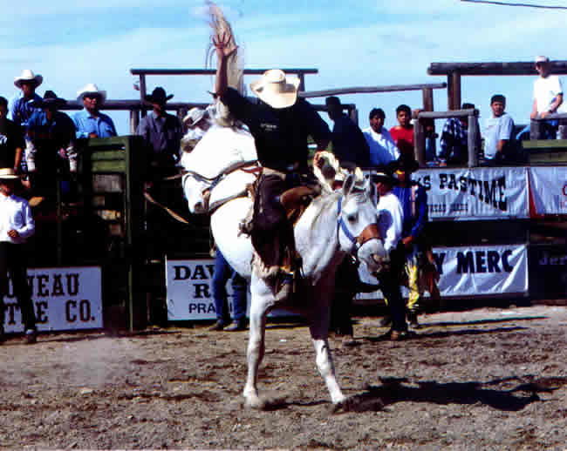

However, my junior year I began to get sick and my bronc riding skills began to go downhill. Whenever my body would receive a little adrenalin instead of getting excited I would become tired and weak. The mitochondria in my muscles which usually supply strength became shriveled up, causing my muscles to ache like when a person has the flu. Just the thought of riding broncs would make me tired and weak. I would usually sleep right up until the time I had to get on a bucking horse. In high school, not many kids actually rode their horses, so if a person rode a horse, they usually would place pretty high and receive points for the year-end awards. At the state finals it was the same thing. If a person rode all 3 horses at state they were usually guaranteed a trip to the National High School Finals.
Before I would get on a bronc, I would always be tired and weak, and often dizzy. When I would try to kick loose and spur the horse so I could receive more points, I had trouble keeping my balance. Due to the sickness, I hardly ever practiced and except for a hometown rodeo, I never went to any other rodeos besides high school rodeos. I got in a habit of just getting the horses covered my junior and senior year instead of trying to better my spur ride and become a better rider. I would get my horses covered, but picked up many bad habits in the process. I made it to nationals my junior and senior years, and received a scholarship to Walla Walla Community College to ride saddle bronc horses. At nationals my senior year, I tried to loosen up to spur the horses I had drawn, but got bucked off both my horses.

I didn‘t figure it was safe for me to ride anymore due to the fact that I would get dizzy and didn‘t have any strength before getting on bucking horses. I told the coach at Walla Walla I could no longer rodeo and decided to hang up riding saddle bronc horses for a while. For the next 2 years I did not get on any bucking horses and the Lord began to speak to me telling me His plans for my future.

One time at a Bible study, I was praying during our time of praise and worship, and the Lord gave me a picture in which I was making a perfect saddle bronc ride, with Jesus riding behind me. I then saw myself back behind the chutes talking to people about the Lord with a Bible in my hand. I asked the Lord if He wanted me to start riding broncs again and He said He did and gave me a scripture.

He gave me Ezekiel 2:3-5, ―He said: "Son of man, I am sending you to the Israelites, to a rebellious nation that has rebelled against me; they and their fathers have been in revolt against me to this very day. The people to whom I am sending you are obstinate and stubborn. Say to them, 'This is what the Sovereign LORD says.' And whether they listen or fail to listen—for they are a rebellious house—they will know that a prophet has been
among them.

When the Lord had given me this picture and the scripture, I questioned Him wondering what I would say and if I was the right man for the job. The Lord immediately gave me Exodus 4:11-12, ―The LORD said to him, "Who gave man his mouth? Who makes him deaf or mute? Who gives him sight or makes him blind? Is it not I, the LORD? Now go; I will help you speak and will teach you what to say.”

After the Lord gave me the second scripture, I figured the first one was not a mistake and the Lord must have known what He was doing. It sounded good to me and I was excited to be an instrument of God. A few months went by and I had an opportunity to go to Kentucky to work on some race horse farms. I decided to pray about it, and as I was praying I saw Jesus and myself walking down a paved walkway in the middle of a paddock in Kentucky. As we were walking, the Lord was pointing out into the pasture at what I thought were clumps of grass. However, as we walked further the clumps of grass became people that the Lord wanted me to talk to. I took this as a sign that the Lord wanted me to go to Kentucky.

While I was in Kentucky, the Lord continued to minister to me and I had the opportunity to visit with some people about the Lord. It was a very good time. One time as I was praying in Kentucky, I saw Amaia (my wife) and myself walking to Montana with Jesus in between us. We were both holding onto Jesus’ hand, and walked from Idaho to Montana and opened a book. Once we opened the book, flames started coming out of the book and people started gathering around the flames dancing. The place on the map we walked to in Montana looked like it could have been Bozeman, Montana. I had applied to Montana State University in high school, and the rodeo coach agreed to pay for my books and tuition to ride saddle bronc horses for them. Even though this was a better offer and a university, I turned it down to go to Walla Walla Community College because all my drinking buddies were going there. I called the MSU rodeo coach, after not being on a saddle bronc horse for 2 years, and the coach offered me the same deal; books and tuition.

I finished 4 years of riding saddle bronc horses for MSU. Riding saddle broncs paid for my Bachelor of Science degree and most of my Masters degree at MSU. The Lord has taught me an awful lot about life and starting colts through riding saddle broncs the past several years.

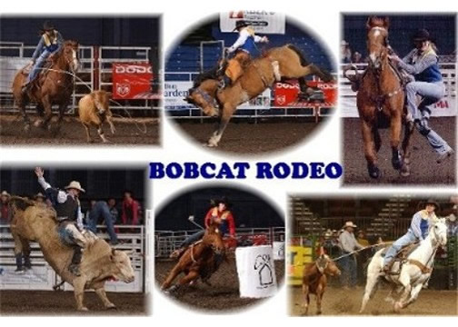

It all boils down to what our focus is: job completion or true unity. When I started riding broncs again after being sick, I had a lot to work through. I had not ridden for 2 years, and the previous 2 years I had ridden sick, developing many bad habits. It took me 4 years to get back on the same track I felt like I was starting on my sophomore year in high school. I would have to say riding broncs is one of my favorite things to do. However, I have had to try to overcome many of Satan’s strongholds. It doesn’t matter what it is, once we have failed in any area of our life, Satan will be right there to remind us of our failures.

Every time I would get on a bronc, I would think about all of the horses that I had ridden tired and weak, and I had an imperfect ride pictured in my mind, consciously or subconsciously. This in turn caused me to not make a good ride. When I started riding again at MSU, it took me another couple of years to try to break all the bad habits and get my head straight again. The Lord showed me one time when I was praying, that I was like Mel Gibson in the movie ―Maverick. He wakes up on the back of a horse in the middle of a desert with a noose tied around his neck and snakes all around the horse’s feet. This was me in my bronc riding. The snakes were all of the negative things I would be thinking about before getting on a horse. I pictured all of the bad rides in my mind, instead of thinking about Christ and making a perfect bronc ride. I was doomed for failure before I even opened the chute gate. As much as I tried, I could not get all the rides of imperfections out of my mind. They continued to haunt me.

Jordan Valley OR

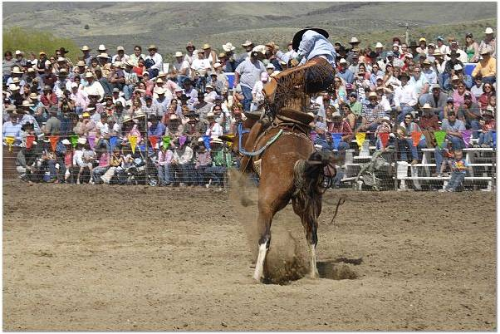

As I was praying, I saw a big wave come through and wash away all the snakes and the noose around my neck. I then saw myself riding in a lush green garden making a perfect bronc ride. This symbolized riding in the flesh and riding in the Spirit. When I am riding in the flesh Satan can get to me and keep my focus on the past and all my failures. However, through the power of the Holy Spirit, God can wash away all of our imperfections of the past and we can start over in perfection. When we are focused on job completion (riding broncs) Satan can have a stronghold on us. However, if we become filled with the Holy Spirit and the power of Christ is living through us (true unity) Satan cannot tell us lies.

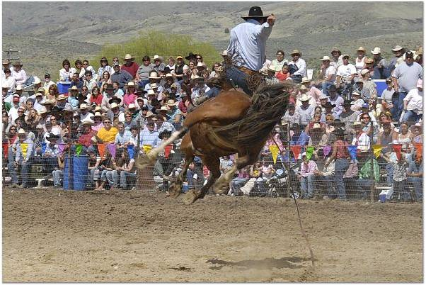
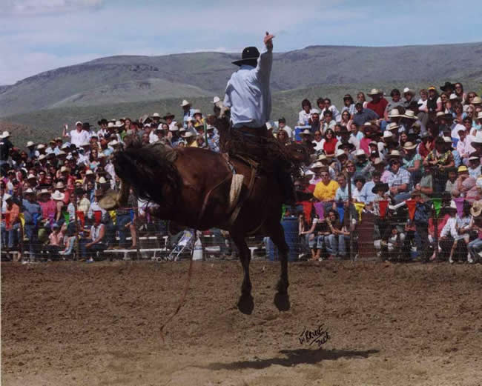.
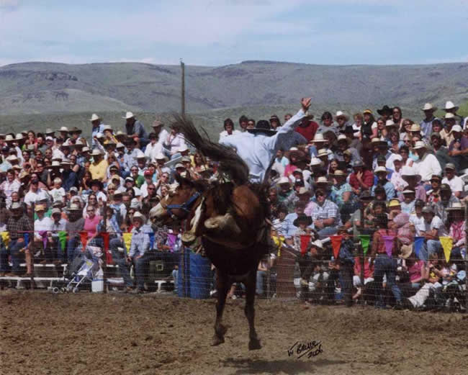

The Lord brought these visions to life the summer between receiving my BS degree and starting my Master’s degree. I entered up and went to 7 pro rodeos. The Lord showed me the power of riding in true unity versus focusing on job completion. The focus of the summer was to be a light for Christ. I did not worry about riding horses, but to love on God and anybody I came in contact with. I won $3,500 in 7 rodeos, but the most amazing thing of that summer by far was the power of riding in true unity/perfection in Christ vs. worrying about job completion.

Preston ID

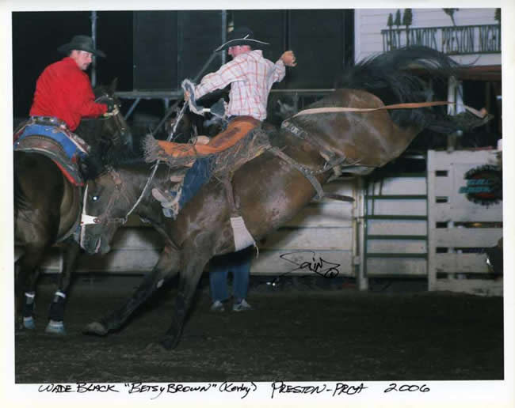

I rodeoed with a couple of kids from Nevada that had a camper, and before I got on every bronc, I would get in the camper, read my Bible and become filled with the Holy Spirit. One time as I was praying, the Lord told me, ―Satan has asked to sift you as wheat (Luke 22:31). This kind of scared me a little bit, so I asked, ―Will you be there Lord? The Lord replied, ―I will never leave you nor forsake you‖ (Joshua 1:5). I then asked, ―Will he hurt me Lord? And the Lord replied, ―The LORD is my strength and my shield; my heart trusts in him, and I am helped‖ (Psalm 28:7). After hearing this, I thought good enough for me, let’s get it on.

I went to the rodeo in Logan, UT and remained filled with the Holy Spirit, talking to people and trying to show the love of Christ. When I got on my bronc, he stalled in the chute, and they hot-shotted him to get him to leave. When they buzzed him out, he reared up and came over on top of me, hitting my head on the back of the chute. I did not end up under the horse and was only a little dazed from hitting my head. I received a re-ride and the next horse I got on was awesome. He came out bucking, just like a bronc rider wants a horse to buck. He bogged his old head to the ground and was kicking at the roof. I was trying to set my feet really hard and spur the horse in the neck to ensure I had a high point spur ride. However, I spurred over my bronc rein and got bucked off.

Getting bucked off is something that really eats on me. Even when I was sick, I hardly ever got bucked off. I grew up riding colts and working on ranches, and whenever a person gets bucked off, they can expect to be made fun of. Getting bucked off is something a cowboy does not like to do. It’s kind of a ―Catch-22. If there is somebody around to catch your horse that is good, but you know you will be made fun of. If there isn’t anyone around, you will not be made fun of, but you may have to walk a long way to get your horse. Cowboys do not like getting bucked off, and this has been a problem in my bronc riding.

When I was sick I would often ―safety-up to get the horse ridden instead of making an 80-point spur ride or get bucked off trying.

Cambridge ID

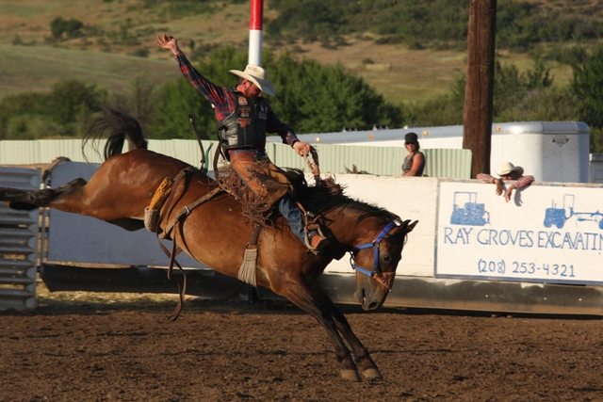

I hate getting bucked off, and this is an area where Satan is able to get into my head and do some damage. Whenever I get bucked off, Satan immediately starts telling me stuff like: ―You suck, ―You must not be a very good bronc rider, to get bucked off, ―Look at all these people that just watched you get bucked off, they think you suck too. For a long time after I was sick, I was scared to get on broncs. Not from getting hurt, but from failure. Whenever I would get bucked off, it would immediately confirm my biggest fear, that I was a failure, that I was not a very good bronc rider. I was worried about what everyone else thought, and as soon as I would get bucked off, I was sure that everyone thought I was a lousy bronc rider. I would tell myself that and eventually I would have myself convinced.

It took me a long time to realize that sometimes even good bronc riders get bucked off. It doesn’t mean that you are a bad bronc rider, you just had a bad day. So, when I spurred over my rein at the rodeo and got bucked off, this was a place that Satan could do some real damage. However, the Lord had already warned me, so it had no effect on me. I went back behind the chutes and did not let Satan’s lies have any effect on me.

During the bull riding they set off some fireworks, and I remember watching a particular firework go off not far from the chutes. There was one spark that came away from the rest, shot clear up in the air and veered off straight behind the chutes. I continued to watch it, and it fell down to the stripping chutes, not 10 to 15 feet from where I was standing and exploded. It did not hurt anyone, only startled everyone, and got everyone’s attention. The Lord then told me, ―Works of fire. The Holy Spirit is a consuming fire, ―For the LORD your God is a consuming fire (Deuteronomy 4:24), and the Lord was showing me that He wanted to unleash His Holy Spirit behind the bucking chutes. I finished off the summer and the Lord continued to speak to me. I had a blast.

Gooding ID

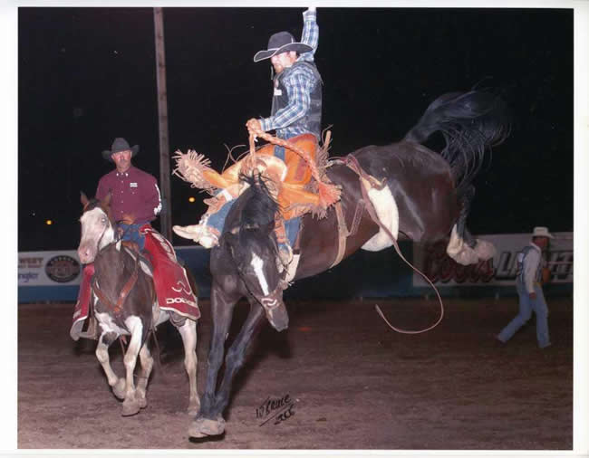

My focus had shifted from job completion to becoming one with Christ (perfect unity). Once a person has found this place, he no longer has to fear the lies of Satan, because the Lord can speak truth to you and warn you of the future, just as the Lord did with me in Logan, UT.

I started back in college in the fall of 2006, and for some reason it did not take long to forget what I had learned during the summer. For the third year in a row I started the spring season winning the saddle bronc riding in one of the toughest regions in the NIRA, the Big Sky region. My focus shifted to job completion, trying to stay in the lead, instead of true unity with Christ. For the third year in a row, it all fell apart at the last rodeo of the season and I barely ended up qualifying for Nationals.

My sophomore year I missed going to Nationals by 6 points. If I would have placed one place higher at any rodeo throughout the year, I would have qualified. My junior year I did almost the same thing, finishing in the fourth spot. I had a horrible last rodeo, and if I would have placed one place higher on my last horse I would have qualified. The team however, qualified in the top two for the region, and because I had been on the team the entire year, I got to go to Nationals. I had pretty good luck at Nationals making it to the short go, but got bucked off a trashy horse in the short go.

So my senior year you would think I would have learned to focus on true unity vs. job completion. Nope, I enjoy banging my head against a wall doing the same thing over and over. Missoula is always the last rodeo and is a double header. I went into the last rodeo winning the region and was focused on winning the region and the saddle that went along with it. I figured after the first 2 years I pretty well had it coming. I thought it was my last year and it was time for the Lord to do a little blessing. After all, I kept a pretty good attitude the last 2 years. This was my time to shine. (I wasn’t quite that arrogant about it. However, I did believe that my senior year would be my year.)

The arena was a standing lake and was a good foot under mud and water. I drew a tiny little colt for my first horse of the last rodeo of the year, and he did come out bucking. He came out and blew in two, jumping and kicking, sucking back. I am not trying to embellish the story, but he did even do a little sun fishing. The horse set up, leaped into the air, and kicked off to the side. While the horse was hanging in the air, I reached up and stuck the horse as hard as I could with my spurs in the neck, listening to the people whooping and hollering behind the chutes.

Missoula MT

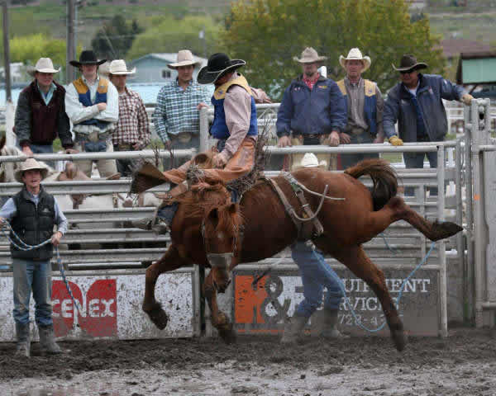

I just remember thinking ―Victory, here we come! The next jump the horse set back on his hindquarters, leaped forward, and drove his head between his legs, launching me over the horse’s head and into the lake of mud and water. It was bad enough that I had been winning the region for the third year in a row and came up short. It was bad enough that for the past 2 years it came down to this particular rodeo. It was also bad enough to be making a good ride and then get ―sucker punched by a wiry little colt, which looked like he had just been pulled off his mother. I also hate getting bucked off, and got bucked off the last horse of the season. But to top it all off, when I did get bucked off, my head was driven into a lake of mud and water and I was covered from head to toe with mud.

As soon as I hit the mud, I bounced up and started to lose control. I wanted to go back behind the chutes and hit something really hard. When I became sick in high school, I developed a temper that kind of scared me. I didn’t just get mad; I would lose control. One of the side effects of the Epstein Bar Virus is a bad temper, and boy, did I have one. I would go from being tired and sluggish, to an out of control maniac. I would feel something come over me, and I would honestly lose total control of my thought processes. I just wanted to tear something to pieces. Looking back, I know this came from Satan, and I can see how he could drive people to do something they never thought they could do.

My temper was often out of control in football my junior year. I wanted to play linebacker, but I had to play corner, a position I hated. Corner takes a little finesse. You have to wait for the person to catch the ball before you can hit them. I had a problem with that concept. I led the league in tackles, sacks and had double the next guy in pass interferences. I liked to hit. As soon as I would get called for pass interference, I would honestly lose control. No one would really get mad at me; they would just try to calm me down and try to keep me from losing control.

I felt like The Hulk. I would try to keep control, but something would take over in my body and I would transform into a mad man. Most of the time when I would get called for pass interference, the following play would be a corner blitz. I do not know where I went during these times, but a mad man would take over. I never snapped on a person outside of football, but would often lose control while working. An example would be the simple task of setting a brace post. I would be working and if something wouldn’t go right, I would lose control and start beating the post until I had nothing left. I would fall to the ground exhausted and sometimes it would take 15 minutes until I had enough strength to get back up (Yeah, pretty stupid).

I had a bad and stupid temper that the Lord has had to help me overcome. I notice that the less time I spend with the Lord, the more tired I become, and the quicker I lose my temper. The more time I spend with the Lord, the more strength and patience I receive.

After getting bucked off, I felt one of these temper tantrums start to billow up. I had the urge to throw and kick anything I came in contact with. However, I kept my composure. I took a deep breath and had the Lord give me some perspective. I then sucked it up and helped the competition that would end up beating me. Helping the competition felt good. This is what being a light for Christ is all about. Besides, maybe if enough light shined through, it would help dry out some of the mud I was caked with.

Once the rodeo was over, I had officially come in third place, again. I could only laugh and think, ―Well, I guess I am just going to have to win Nationals. Before I could leave, I had to go to the awards ceremony to receive my third-place award, and of course, be a good sport and let my light shine; blah, blah, blah. Well, when they announced the bronc riding champion, who do you think they announced? None other than yours truly. I was the 2007 Big Sky Region Saddle Bronc Riding Champion. I went up and got my picture taken holding my newly engraved champion trophy saddle. I thought surely, they had made a mistake, but who knows, we serve a mighty God. Maybe even through all this the Lord had found a way to bless me.

Nope, they had made a mistake. I was still in third place. However, it felt good to be humiliated and humbled a little further. I guess I had not quite had enough mud thrown in my face for the day. Oh well, I figured I was just being tested and that I would get them at Nationals. I mean who cares about being the Regional Champion when you could be the National Champion. So I had it in my mind that I would just stand on faith that I was going to win Nationals.

National College Finals Rodeo

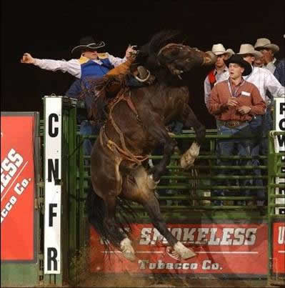

So, did I end up winning Nationals? Well, let me tell you the story. The first horse I got on was supposed to have some ducks and dives, but ended up being straight down the pen, a nice horse. I got tapped off and was thinking, ―This is fun. This will be a good horse to start off on. I was looking under my rein, watching my feet reach up and spur him in the neck, just as relaxed as could be, another day at the office. The horse was following the pickup man and for some reason I looked to see how close the fence was. Right then the horse threw his head up, sucked back underneath me and threw me to the ground. I made a great 7-second spur ride.

National College Finals Rodeo

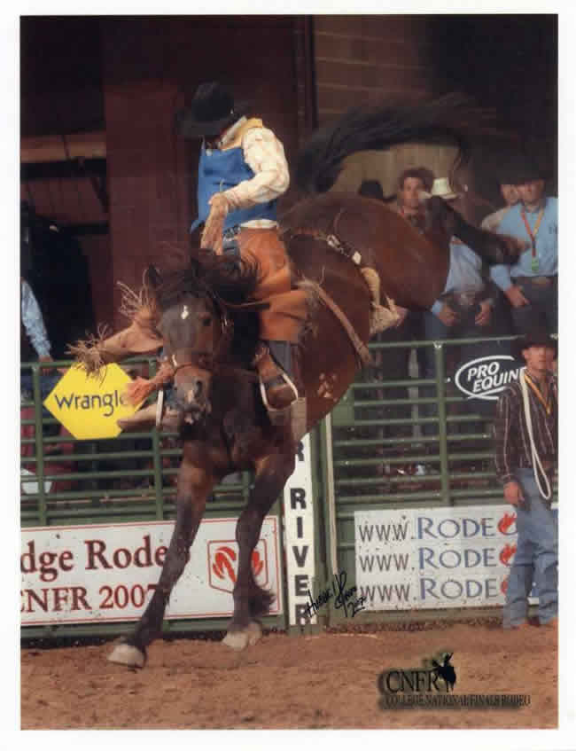

Needless to say, this did not quite line up with my plans of winning the National Finals. I tried to keep a good attitude, but was kind of discouraged and was a brat to Amaia. Before getting on my second horse, I thought, ―I need to spend some time with the Lord. I needed to get filled with the Holy Spirit like I did last summer. I laid down behind the chutes on my bronc bag and began to pray. The Holy Spirit began to come and the Lord began to speak to me. I remembered what He had told me about having the noose around my neck and worrying about stuff, instead of focusing on being one with Him. He told me I need to be filled with love. ―Love is patient, love is kind. It does not envy, it does not boast, it is not proud. It is not rude, it is not self-seeking, it is not easily angered, it keeps no record of wrongs‖ (1 Corinthians 13:4-5). As I went through the list, I started to see where I had fallen short in so many ways.

National College Finals Rodeo

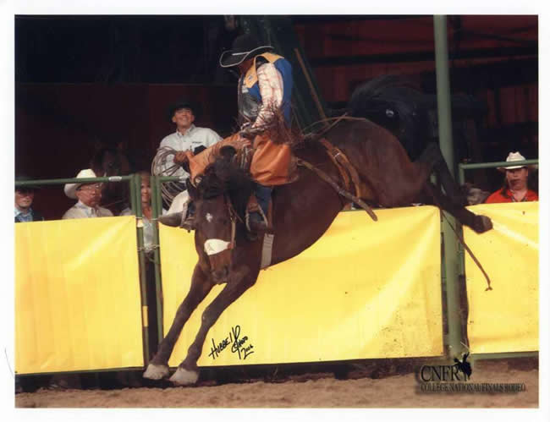

I asked the Lord for forgiveness, and as I got up and prepared to get on my bronc, the Lord showed me that I was like Peter when he stepped out of the boat and tried to walk to Jesus. ―Lord, if it's you,‘ Peter replied, tell me to come to you on the water.‘ Come,‘ he said. Then Peter got down out of the boat, walked on the water and came toward Jesus. But when he saw the wind, he was afraid and, beginning to sink, cried out, Lord, save me!’ Immediately Jesus reached out his hand and caught him. You of little faith,‘ he said, why did you doubt?’ (Matthew 14:28-31). Peter steps out onto the lake on faith and begins to walk on the water. However, when he sees the wind and the waves crashing down, he begins to lose faith and starts to sink. The Lord showed me that’s how I am with my bronc riding. I try to step out on faith that I am healed and that I no longer have anything holding me back. I start out ok looking only to Christ, but as I get out in the water my focus shifts to the mighty waves and I start to sink. I begin to think about imperfect rides I made in the past and trying to prevent them from happening again. I begin to shift from being united with Christ to worrying about job completion, and I begin to sink.

I felt awesome before getting on my second bronc. I was no longer thinking about the poor rides I had made in the past, and was focusing on glorifying God and spurring this horse harder than I had ever spurred a horse before. All I thought about was setting my feet and making a perfect spur ride. I got on my horse, called for the gate, and spurred the horse for all I was worth. The horse bucked in a tight circle to the right. I was trying to set my feet as hard as I could and was making a good ride. At 7 seconds I hung my right spur for a split second and the horse sucked back to the left sending me flying right on my head. I had gotten bucked off another horse! As soon as I pulled my head out of the dirt, I imagined Peter and I said, ―Lord, you make it hard to step out on faith, because when I do I get pounded by the waves.‖ I was a little frustrated, but bounced back knowing that the Lord had a plan and through all this He was teaching me. The last horse did not go well either. I was thinking too much about the previous 2 horses and got bucked off right out of the chute.

National College Finals Rodeo

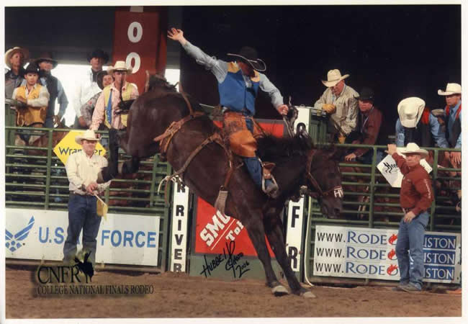

Once I got home from the Nationals the Lord began to speak to me. He showed me many things and why things had to happen the way they did at Nationals. When I returned home, the Lord showed me in a vision a cow that had been drinking from a dirty watering hole in the middle of the dessert that was full of mud and manure. The cow was very skinny and sickly looking. He then showed me another cow drinking from a spring shooting out of the side of the mountain that ran off the rocks. The water was crystal clear and watered a lush green valley. He showed me that the 2 cows were me. I had not been spending enough time drinking of the Holy Spirit (spring) and had been spending too much time in the world (muddy watering hole).

He began to show me the importance of true unity instead of job completion. All spring I had been focused on job completion, winning the region, winning the nation. My focus had been riding broncs instead of solely loving God and trying to be a light for Christ.

The summer I did so well in the PRCA I was not focused on what other people thought, but only on serving the Lord. The Lord showed me that riding broncs was my ministry and that was my focus. I went to the rodeos and was not concerned about winning money and selfish ambitions, but being a light for Christ. The Lord in turn took care of me tremendously blessing me with $3,500 in 3 weeks. He was supporting my ministry. During the week I would try to prepare for the weekend like a pastor would for church. I was starting colts and thought about God all day and read my Bible whenever I got a chance. I listened to Christian tapes when I was in the car and my whole life was consumed with God.

However, when I started going to the college rodeos my focus began to change. I became busy, and I did not make time daily to spend with the Lord. Riding broncs went from being my ministry to being my job. I had the expectations of the team and team supporters and I did not want to let them down. I went from being totally consumed with God to drifting back into the world. I went from having no weight on my shoulders in the PRCA to carrying the weight of everyone‘s expectations. I went from true unity to job completion.

Bozeman MT

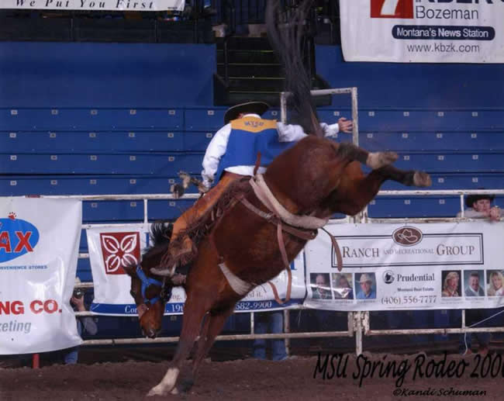

I needed to get bucked off all my horses at the National Finals. The Lord needed to teach me something: riding broncs was going to be part of my ministry. When the Lord had told me to start riding broncs again, the only broncs I had gotten on were at college rodeos. Every summer I would say I was going to ride broncs, but would get too busy working and not go to any rodeos. By the time I was 24, the most rodeos I had ever been to during the summer was 8, followed by 5 rodeos and then maybe 1 or 2.

Jordan Valley OR

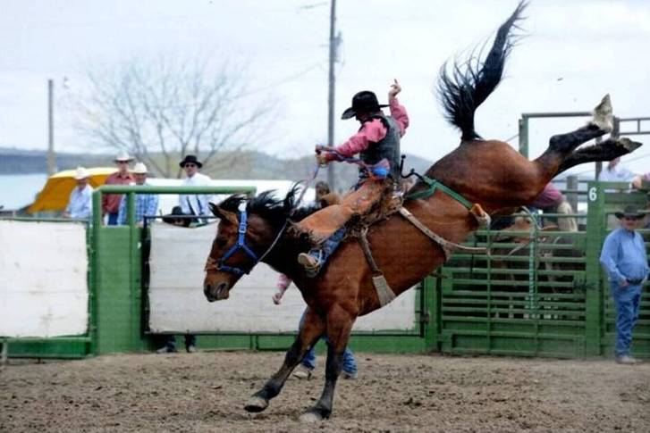

However, after the College Finals, I had to ask myself some questions. I had been bucked off 3 horses and was finished with college rodeos. Do I hang it up and let Satan convince me that I am bad bronc rider and there is no point of going? Or do I stand on the promises from God and get serious about riding broncs? I have decided to stand on God’s promises. I am going to get serious about riding broncs and try to enter as many rodeos as God allows me. God always has a plan and He always has your best interests in mind. If I had not gotten bucked off all my horses at Nationals, I might not have been motivated to start rodeoing hard. I am having a lot more fun rodeoing at the professional level than I ever did at the college or amateur level, and this is where my ministry is, which makes it all the more fun.

Pasco WA

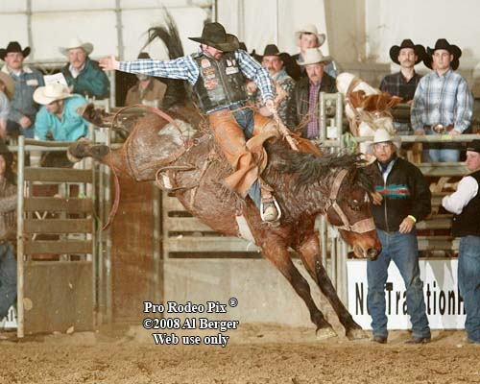

Through all this the Lord has taught me the importance of true unity instead of job completion. Any time we take our focus off of God and start thinking about completing a job, Satan can come in telling us lies and deceiving us. It doesn’t matter whether it is in sports or in any area of our life. 2 Kings gives us a great example of true unity vs. job completion, ―When the servant of the man of God got up and went out early the next morning, an army with horses and chariots had surrounded the city. Oh, my lord, what shall we do? The servant asked. ‗Don't be afraid, ‘The prophet answered. Those who are with us are more than those who are with them. ‘And Elisha prayed, O LORD, open his eyes so he may see. ‘Then the LORD opened the servant's eyes, and he looked and saw the hills full of horses
and chariots of fire all around Elisha‖ (2 Kings 6:15-17).

Jordan Valley OR

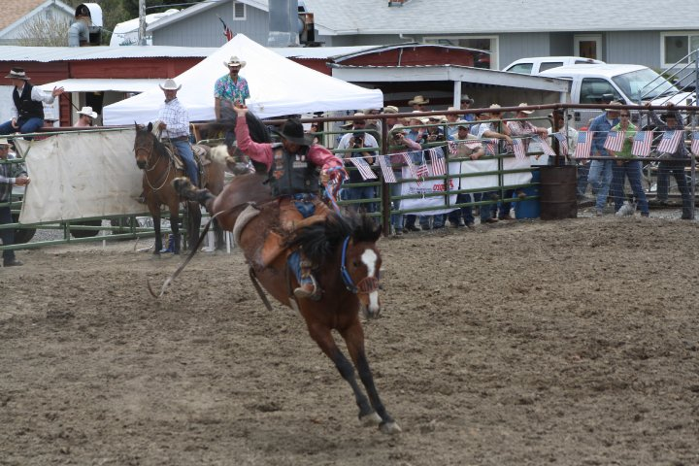

The servant was focused on job completion. They were terribly out-numbered and were certain to be slaughtered. However, Elisha the prophet had true unity with Christ. He had a different perspective on the same situation. Because God had opened his eyes to see into the heavenly realms, he could see that God was in total control and had a massive army behind Elisha.

Pasco WA

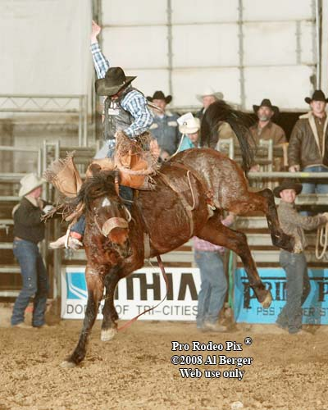

Through true unity comes communication. When I would take time to get filled with the Holy Spirit and wash away all the worries and cares of the world before getting on a bronc, this is when the Lord would speak to me. He told me to start riding broncs again and told me what college to go to. After I had started riding, He showed me that I need to become filled with the Holy Spirit and He will wash away all the lies that Satan tells me. He warned me in Logan, UT that Satan was going to try to deceive me. God helped me to see into the future, so I was not surprised at what the future would bring. He also showed me that I need to love and not get caught up in worldly things, otherwise like Peter, Satan can deceive me when I step out into the water.

Great Falls MT Circuit Finals

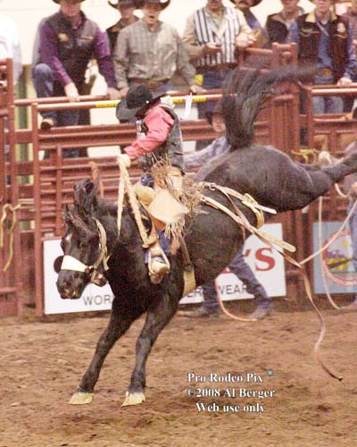

Through all these things, God took off the covering of what I could not see with my natural eyes and helped me to see what the Lord was supernaturally working in my life in the past, present, and future. Through true unity and being united with Christ, He is able to communicate with us and direct us on the path that He has set before us. The same thing happens with our horses.

